Exercise List

# Rian Koja

# CAP 239 Computational Mathematics

## Exercise 1

### GRNG

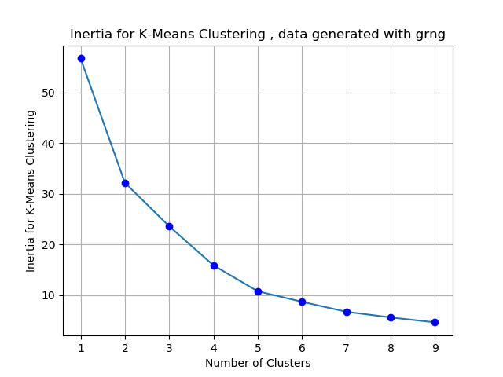

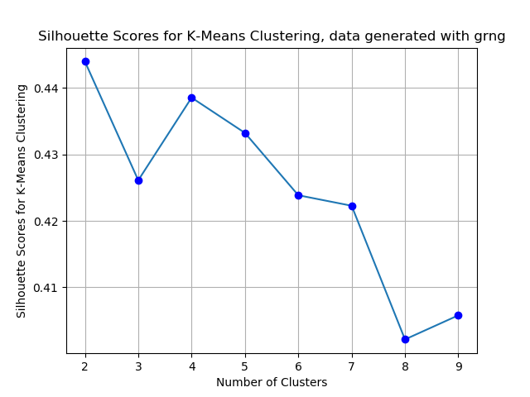

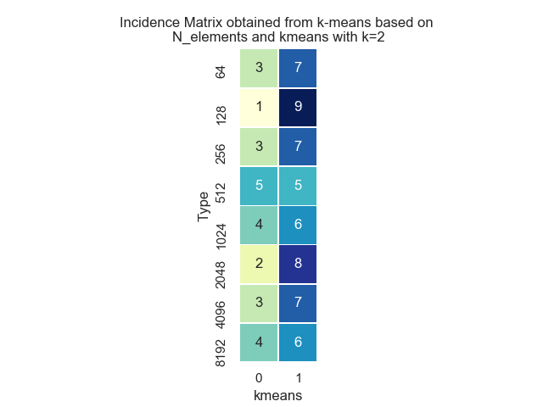

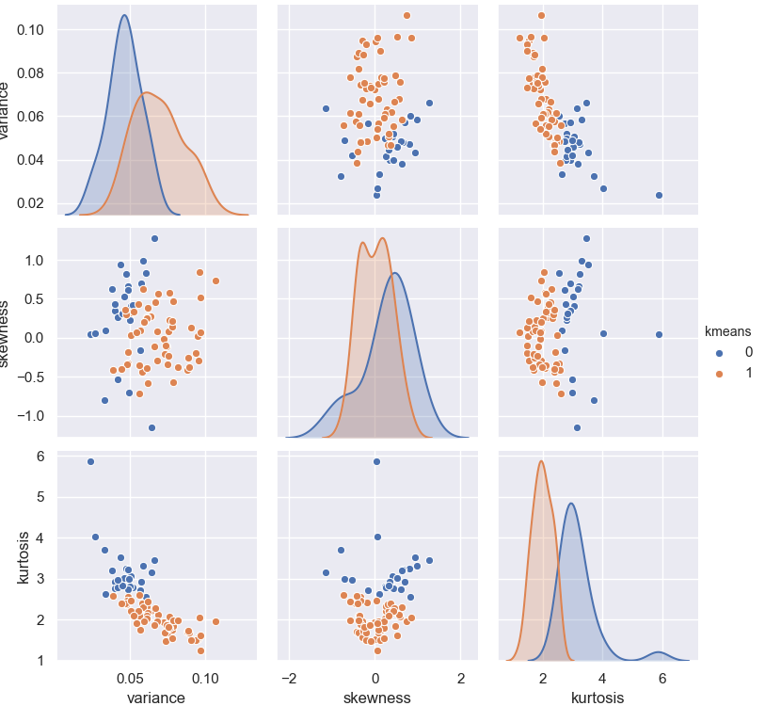

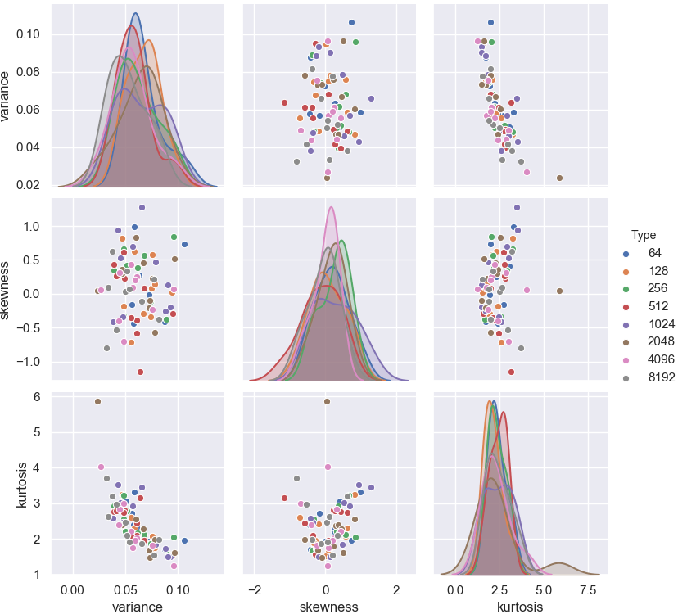

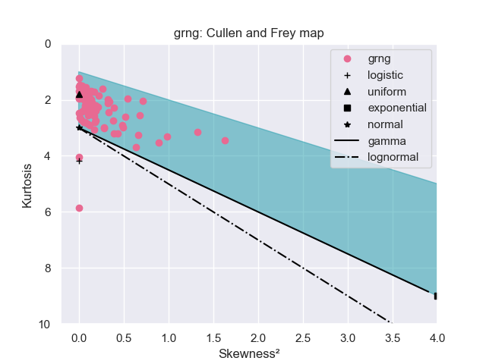

## Exercise 2

### Colored Noise

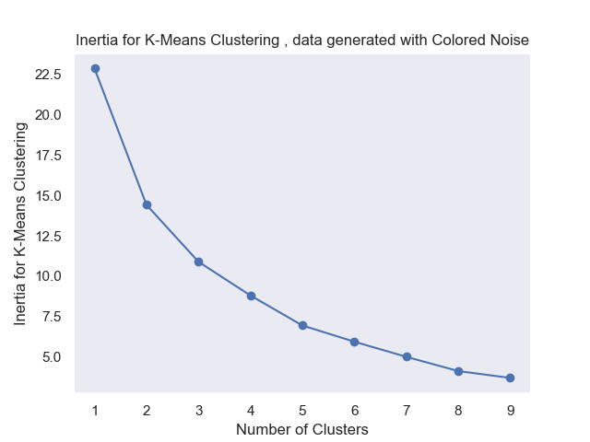

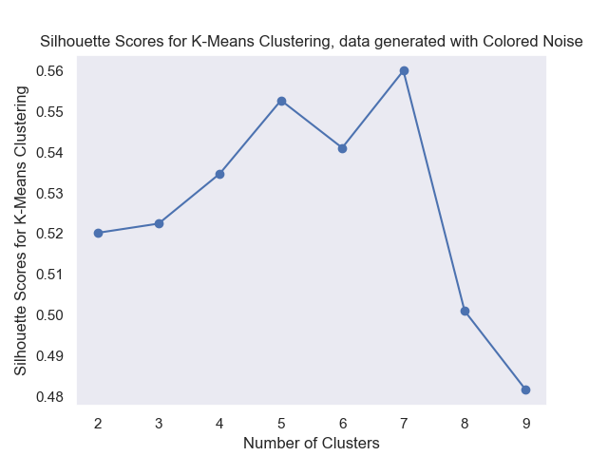

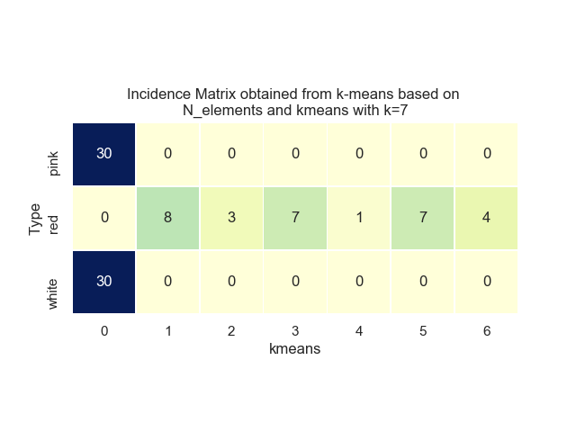

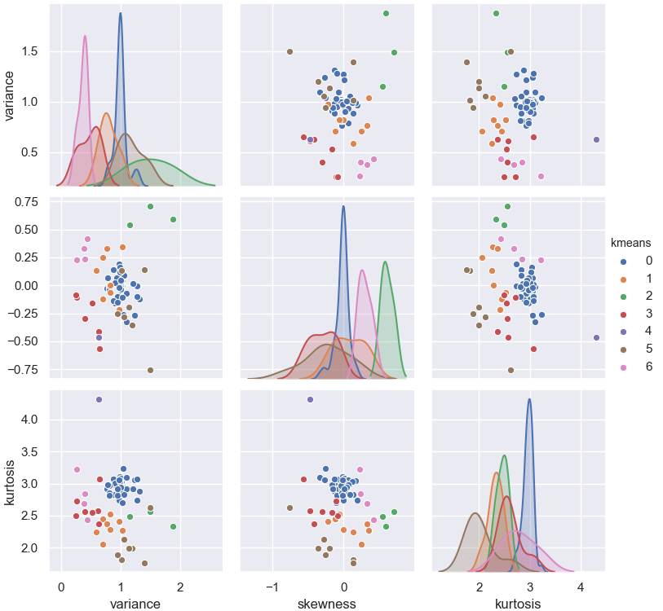

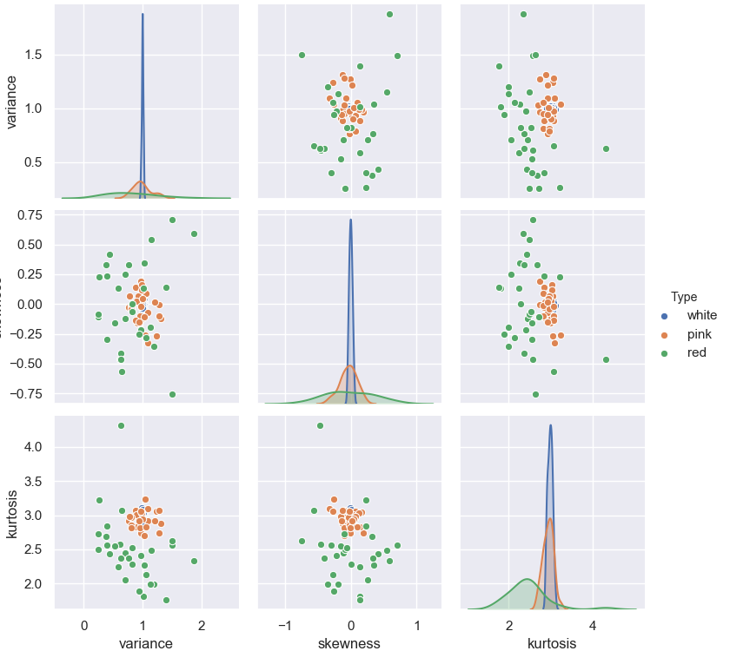

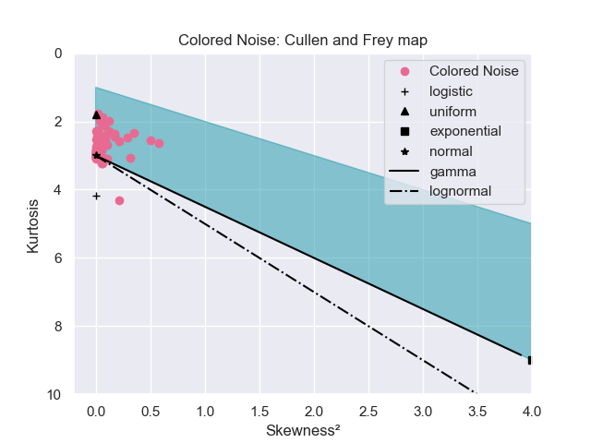

## Exercise 3

### P-Model

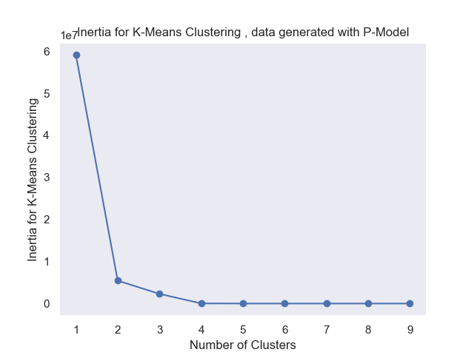

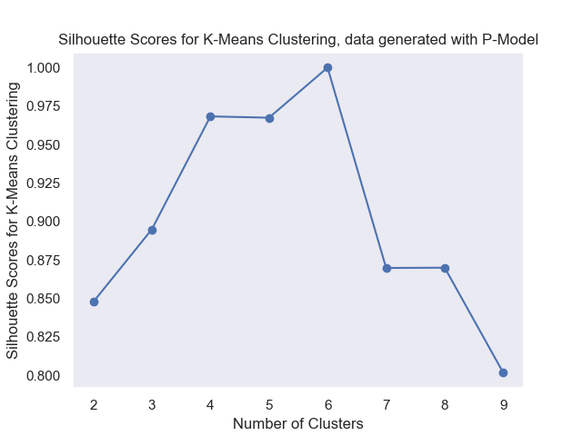

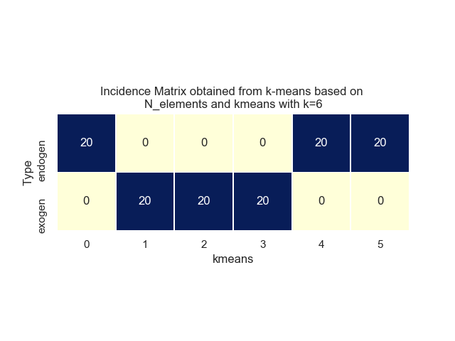

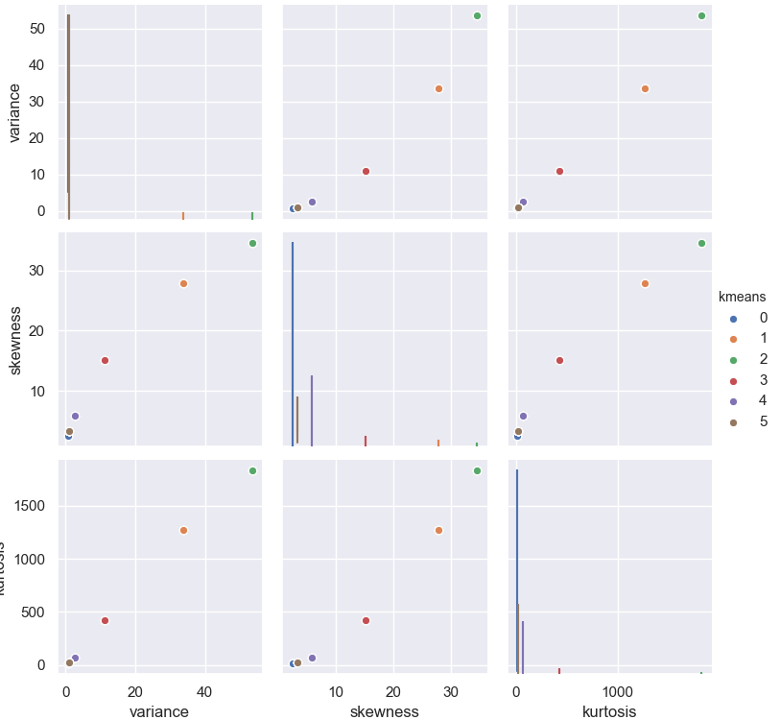

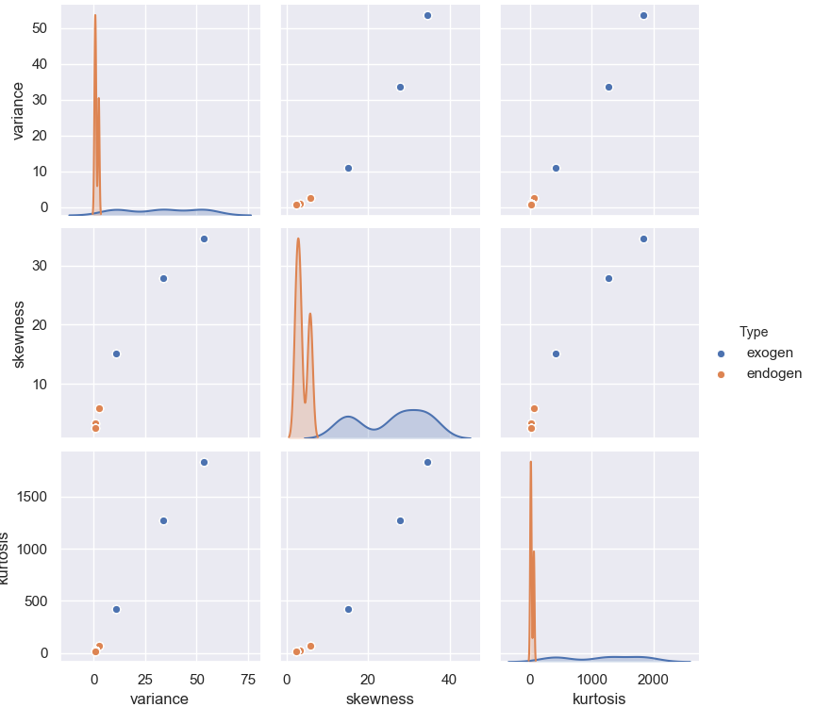

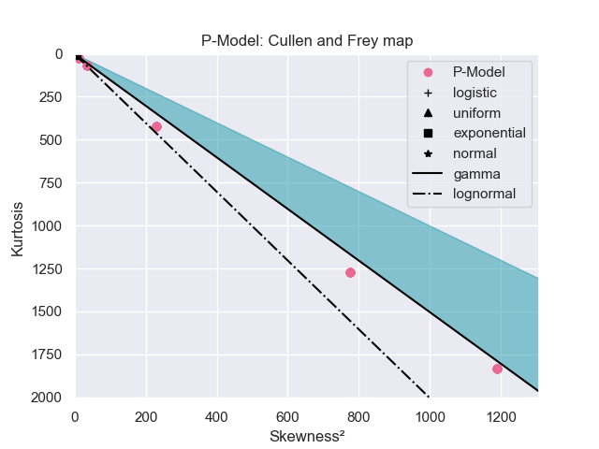

## Exercise 4

### Exercise 4.1

This exercise produces results for each of the generators used in the prior exercises, thus such results were shown in the previous sections.

### Exercise 4.2

Here we compare different methods of estimating a probability density function from sampled data.  
The first is to use Kernel Density Estimation, a standard method to compose a PDF as a pondered sum of PDF's centered at each observed point.  
The second is a parametric estimation, done for both Gaussian distribution and Generalized Extreme Value distribution. With this technique, a best parametric fit for the observed data is found, and the curve is plotted based on the parameters found.  
For each kind of noise, the type is indicated in the plot title, along with the values estimated for parameters.

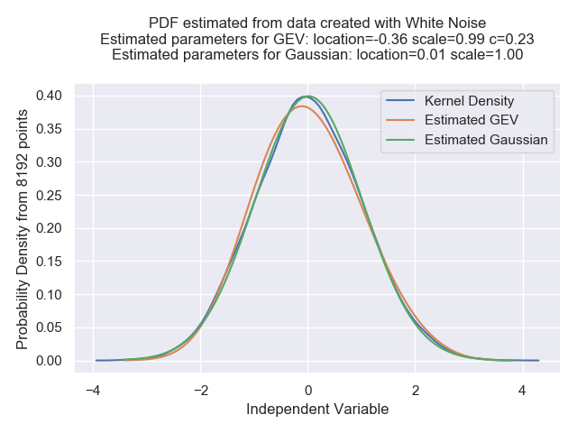

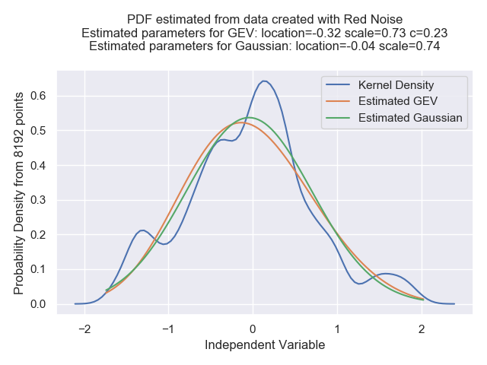

## Exercise 5

For Henon map:

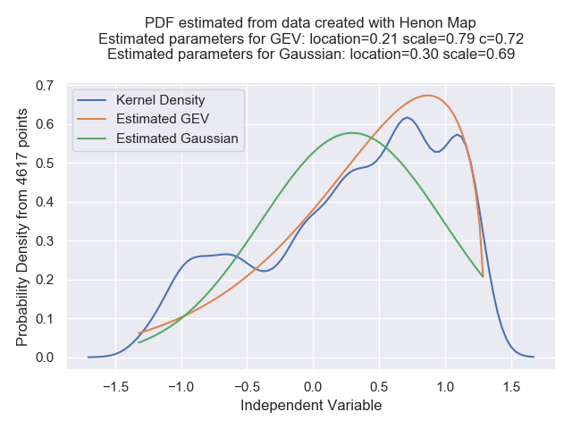

For Logistic map:

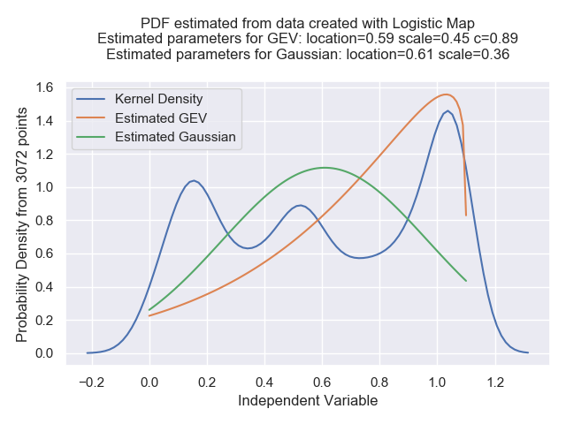

## Exercise 6.1

The P-Model will be excluded, since it provides data series with high kurtosis and skewnessthat would prevent effective clustering with K-Means

### For Non Gaussian Random Generator:

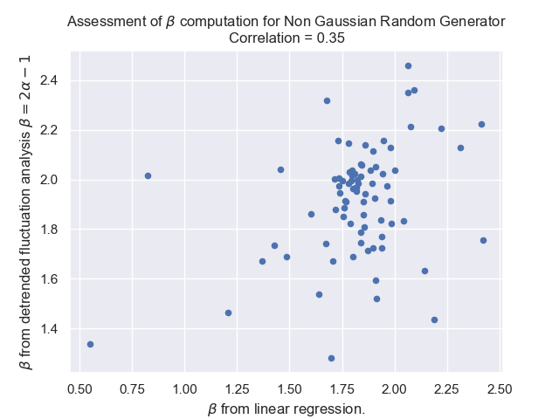

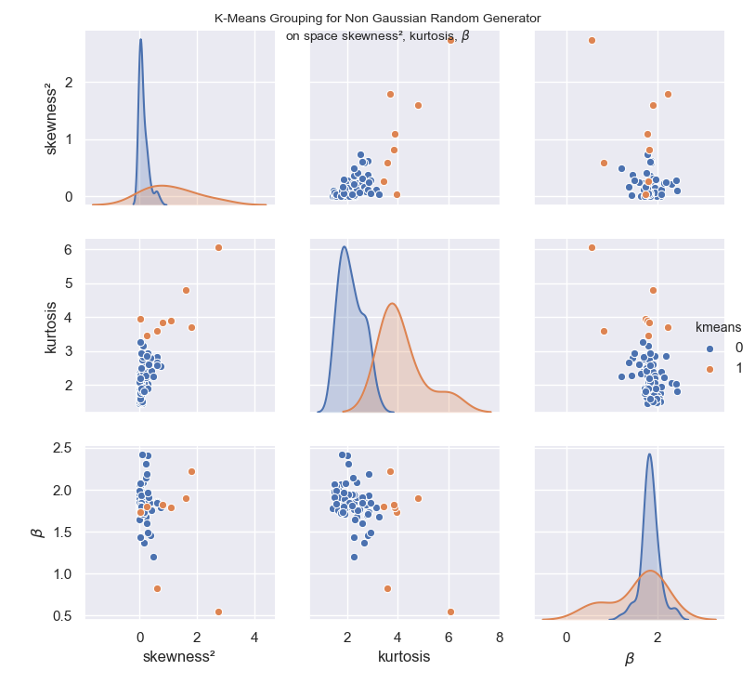

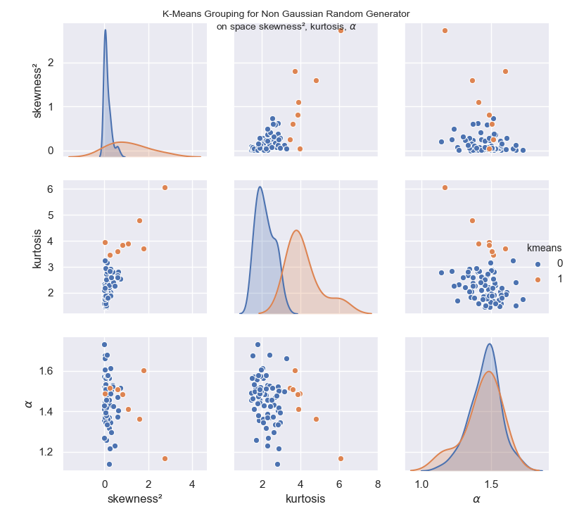

### For Colored Noise Generator:

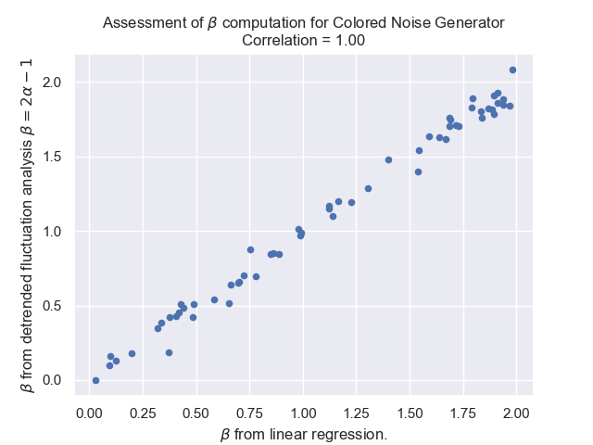

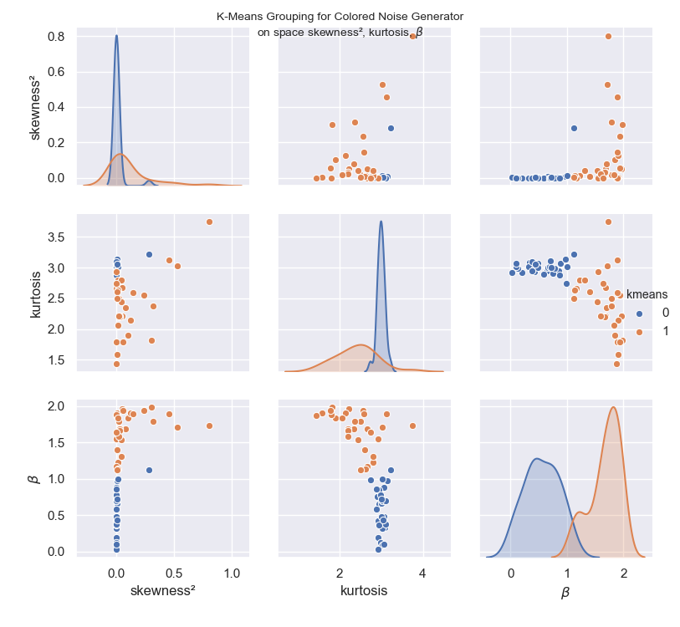

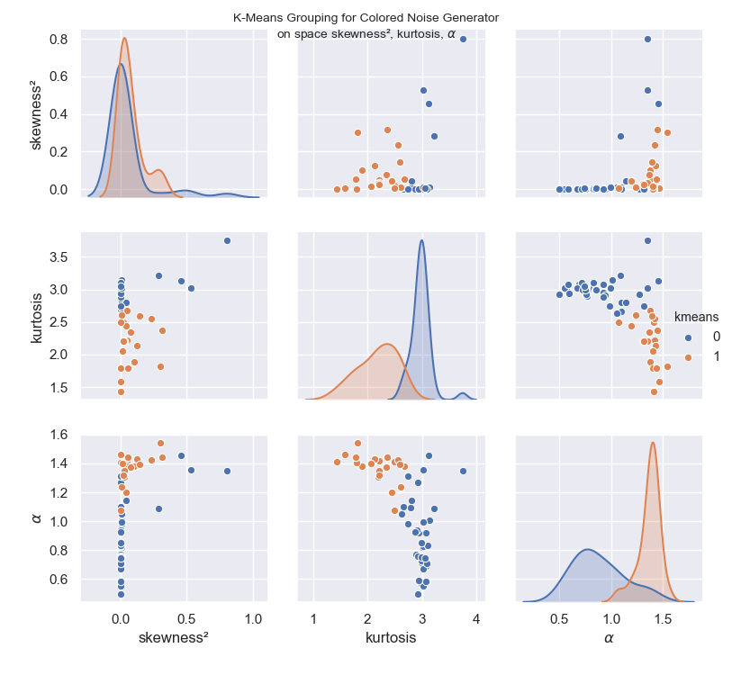

### For Logistic Map:

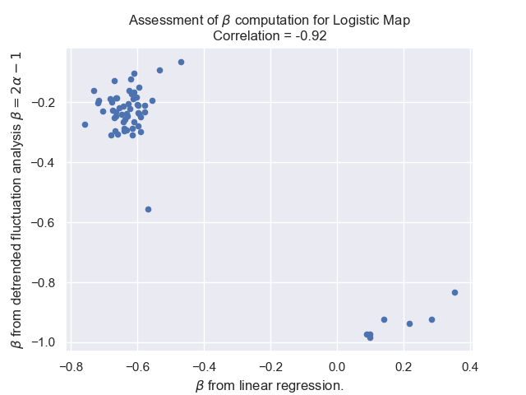

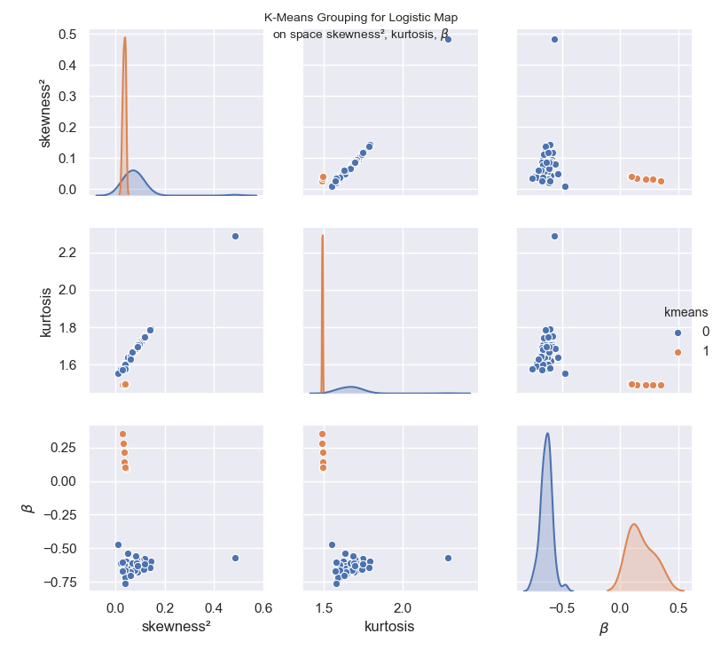

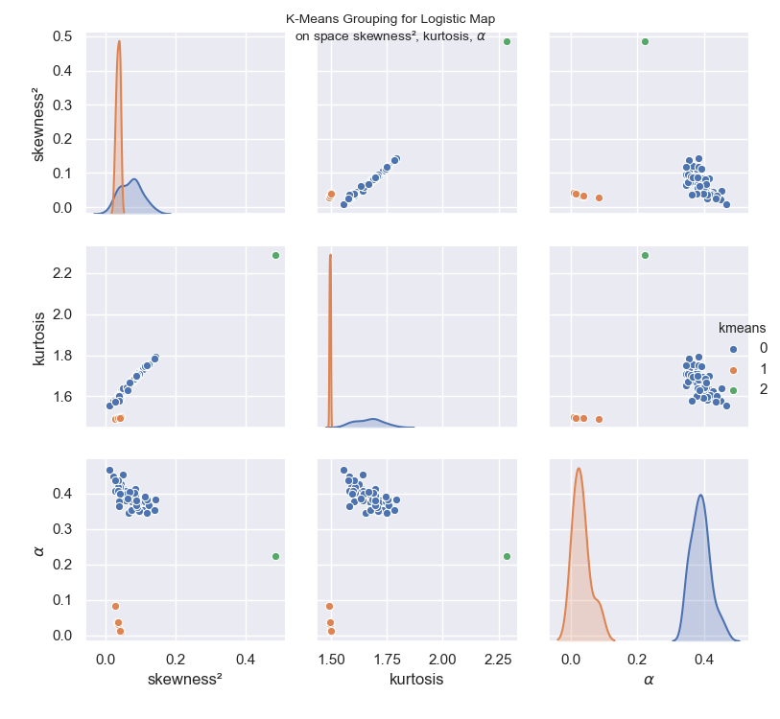

### For Henon Map:

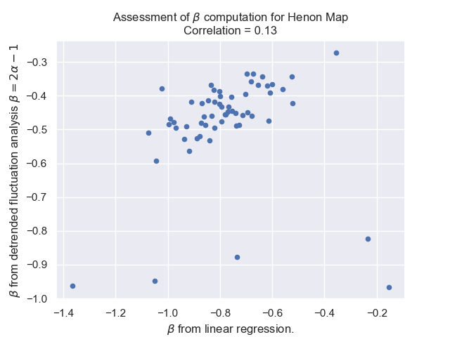

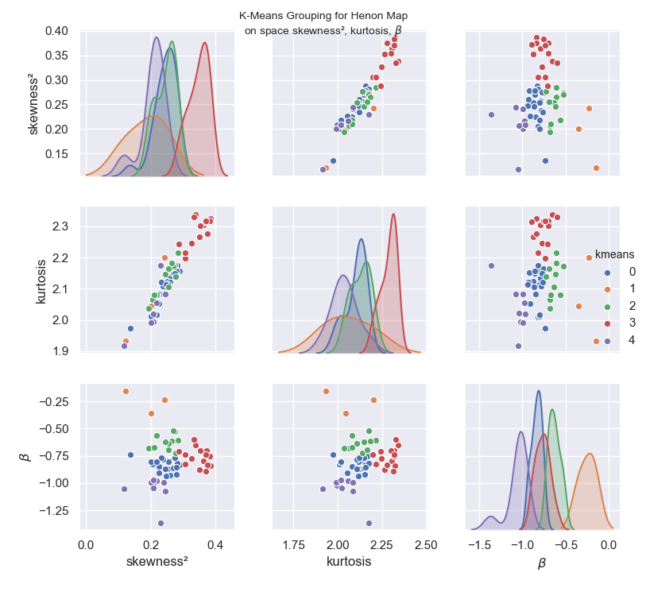

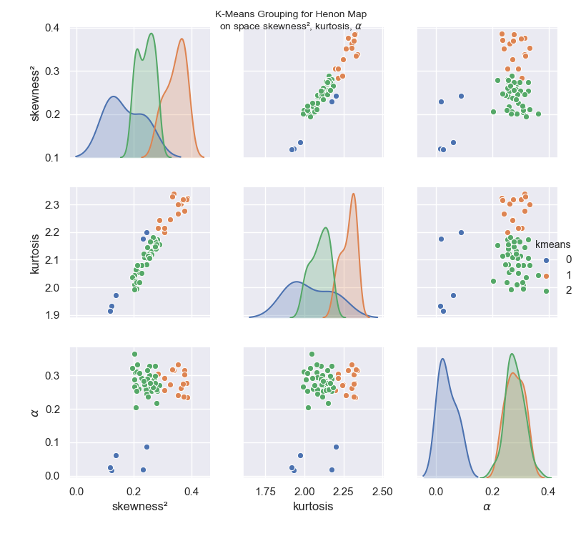

### Combining all data series:

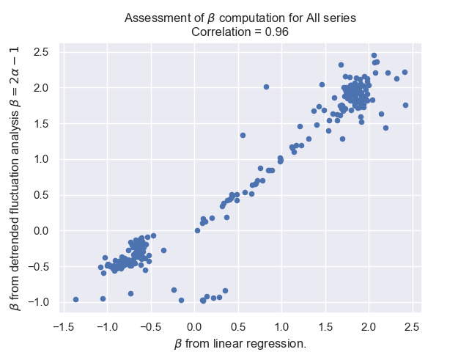

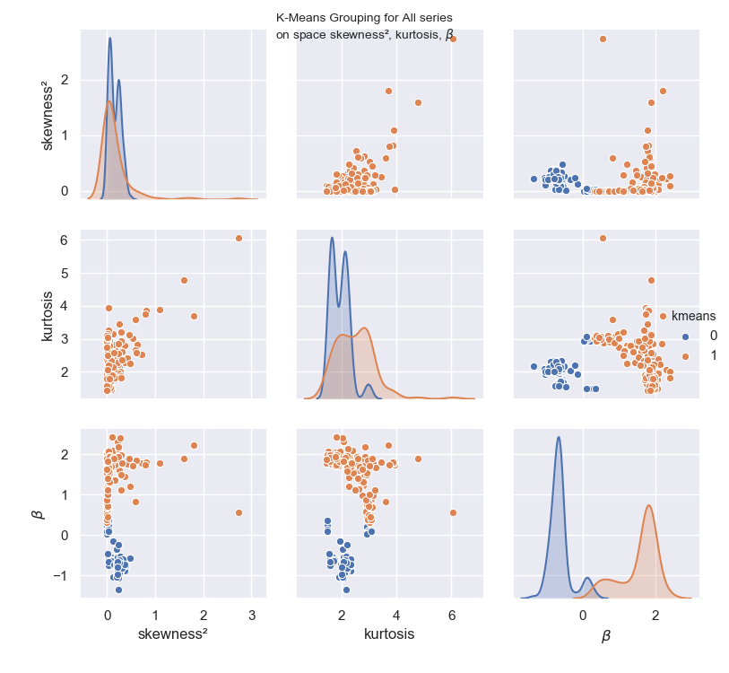

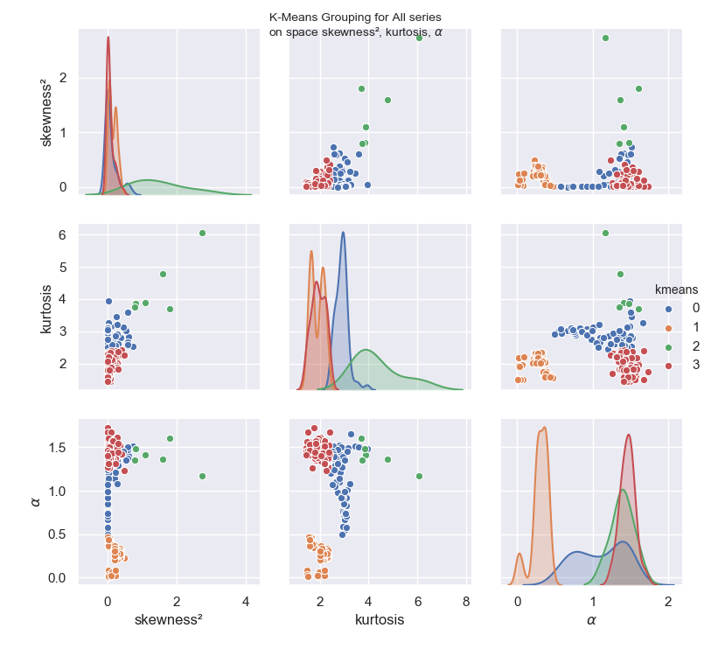

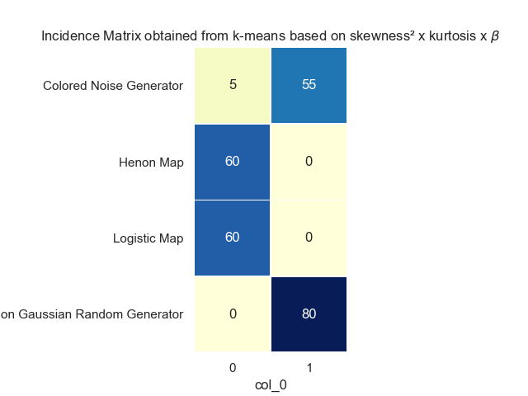

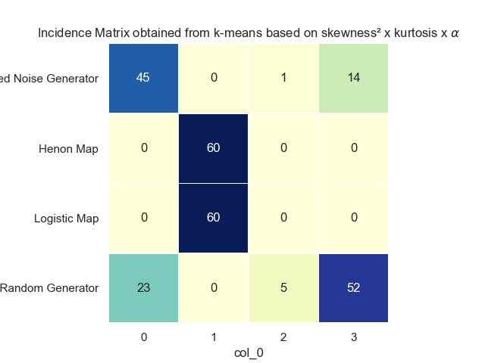

## Exercise 6.2

Using provided data sets and new cases of COVID-19 in the USA.

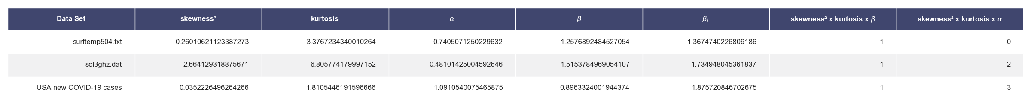

All datasets would get classified on the same group, if P-Model was included on the training data, since the grouping would basically be dominated by the high kurtosis and skewness of p-model series.  
It can be seen that the behavior of the US series was clustered along with the colored and non-gaussian noises, which makes sense assuming that the number of new daily cases should be directly proportional to the number active cases, more specifically the number of people in the contagious stage of the disease, which in turn is dependent on the number of new cases of a few preceding days. While this makes sense for more closed regions, the US seems to have a dynamics of the disease spreading at exponential rate initially once it reaches a new state or city, thus the closer similarity to the Non-Gaussian noise behavior instead of the colored noise.

Meanwhile, the data series in surftemp504.txt and sol3ghz.dat, are clustered with the random noise in the space with beta, but particularly the sol3ghz.dat gets isolated in its own group when clustering with alpha. Given the correlation between alpha and beta, this might just be an effect of the lack of normalization or scaling prior to applying the K-Means technique. It might also be an effect of the data being

## Exercise 6.3

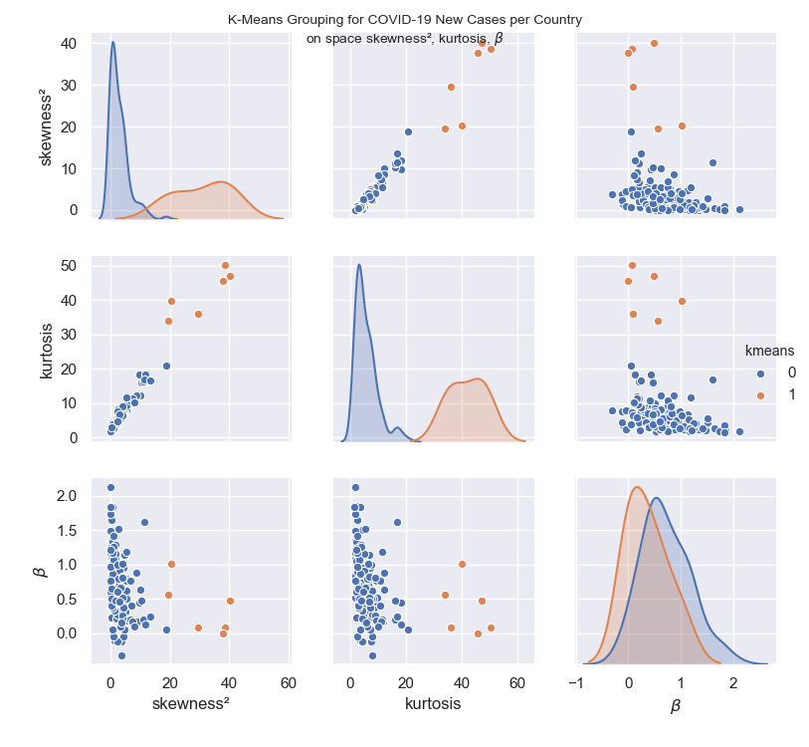

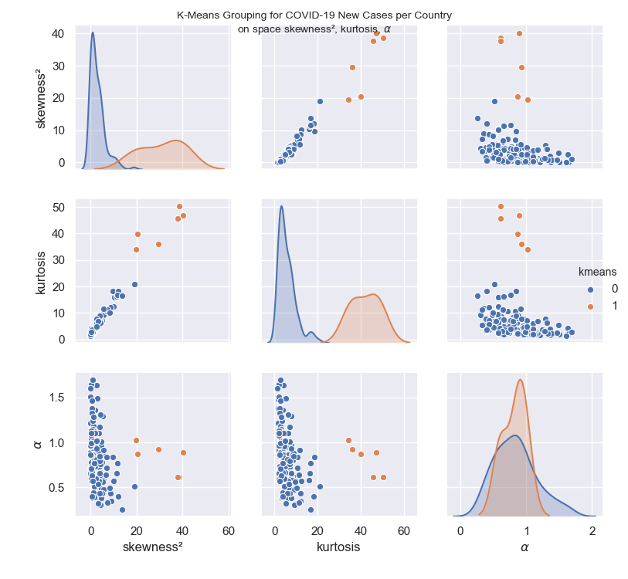

Below is the data set created for most countries available in the data collected from "Out world in Data" website. Only countries with a minimum data diversity were selected, bychecking if the number of new cases had assumed at least 12 distinct values. This eliminates time series that are simply too short or that do not contain enough data richness to apply the available tools. Also, countries with negative alpha were removed. The maximum silhouette coefficient method was employed to select the number of clusters, which ended up being 2. The main group has hte majority of countries, whereas high kurtose, high skeness and high alpha or beta, which apparently correlates with countries in early stages of the epidemic, where daily new cases are growing steadily rather than slowing down or retreating.

skewness² kurtosis $\alpha$ $\beta$ $\beta_t$ name kmeans beta group  
0 4.647446 7.756279 0.966141 0.766339 0.932281 Togo 0 0  
1 0.202633 2.272529 1.135226 1.249922 1.270453 Singapore 0 0  
2 0.072929 1.772419 1.215279 1.336563 1.430557 Algeria 0 0  
3 2.543750 6.383607 0.803547 0.712848 0.607095 Macedonia 0 0  
4 0.467714 2.223767 0.843263 0.529438 0.686526 Pakistan 0 0  
5 1.325827 3.682514 0.441773 0.436024 -0.116454 Uruguay 0 0  
6 1.321560 3.798519 0.877235 0.509976 0.754471 France 0 0  
7 3.654967 6.299366 0.504531 0.287476 0.009061 Sudan 0 0  
8 3.886317 7.784038 0.661907 -0.316456 0.323815 Cameroon 0 0  
9 3.879811 7.045874 0.853518 0.845341 0.707035 Myanmar 0 0  
10 3.659337 7.036886 0.727027 0.507892 0.454054 Georgia 0 0  
11 0.444545 2.184726 0.909326 0.497906 0.818652 Peru 0 0  
12 2.492821 4.352133 1.637202 1.506640 2.274404 Chile 0 0  
13 9.706140 18.395726 0.841184 0.438294 0.682368 China 0 0  
14 3.594521 6.201451 1.102278 0.951210 1.204556 Montenegro 0 0  
15 1.167060 2.684966 1.179206 0.822807 1.358412 Kuwait 0 0  
16 0.333079 2.064823 0.986030 0.831893 0.972059 Slovenia 0 0  
17 0.413701 4.026314 0.776916 0.738677 0.553832 Cote d'Ivoire 0 0  
18 0.957196 3.755020 0.877549 1.162930 0.755098 Bulgaria 0 0  
19 1.980367 4.953904 0.736824 0.500563 0.473648 South Korea 0 0  
20 4.116856 8.334815 0.804549 0.351340 0.609097 Kosovo 0 0  
21 0.652697 3.040954 1.114867 1.098999 1.229733 Costa Rica 0 0  
22 5.630992 8.607220 0.620269 0.372801 0.240539 Jersey 0 0  
23 0.580288 2.222109 0.586031 0.222557 0.172062 Somalia 0 0  
24 4.355623 7.274639 0.666348 0.568510 0.332696 Guam 0 0  
25 4.367243 9.211022 0.307865 0.454081 -0.384270 Sierra Leone 0 0  
26 10.334728 16.079743 0.578482 0.473743 0.156965 Maldives 0 0  
27 1.908388 3.813335 0.789786 1.098861 0.579572 Honduras 0 0  
28 0.384417 2.735915 0.578744 1.645986 0.157488 Tajikistan 0 0  
29 8.972552 12.010376 0.349534 0.168227 -0.300932 Syria 0 0  
30 2.092928 4.303206 0.511801 0.207270 0.023603 Oman 0 0  
31 0.000673 1.821226 0.956070 0.523371 0.912141 United Arab Emirates 0 0  
32 0.297407 2.558764 0.904479 0.965095 0.808958 Albania 0 0  
33 11.290277 16.197713 0.660308 0.197044 0.320615 Venezuela 0 0  
34 0.152061 2.919419 1.044353 1.167258 1.088706 Canada 0 0  
35 1.042293 4.947976 0.664174 0.457088 0.328348 Puerto Rico 0 0  
36 1.015743 3.076024 1.143290 0.565450 1.286580 Egypt 0 0  
37 3.834250 7.720627 0.612823 -0.118128 0.225646 Yemen 0 0  
38 1.450362 3.282174 1.117322 1.236345 1.234644 Brazil 0 0  
39 0.288073 4.320171 0.604945 0.372235 0.209890 Philippines 0 0  
40 4.721597 6.794799 0.485607 1.141171 -0.028787 Haiti 0 0  
41 0.820070 3.208707 0.388050 0.453605 -0.223899 Guinea 0 0  
42 1.482140 3.066539 1.270363 1.184679 1.540727 Iceland 0 0  
43 0.510387 2.225858 0.915083 1.122868 0.830165 Nigeria 0 0  
44 0.019167 2.872680 0.887326 0.702098 0.774651 Panama 0 0  
45 1.956095 3.964485 1.356571 0.913118 1.713141 Luxembourg 0 0  
46 0.422834 2.049792 1.125249 1.349688 1.250499 Qatar 0 0  
47 5.814925 9.857183 0.568762 0.511908 0.137524 Swaziland 0 0  
48 1.316442 3.155491 1.024742 0.846136 1.049484 Andorra 0 0  
49 1.702694 4.420856 0.792823 0.540704 0.585647 Greece 0 0  
50 10.118350 12.349369 0.574627 0.626456 0.149255 Mauritania 0 0  
51 4.510562 7.653448 0.600100 0.249293 0.200201 Chad 0 0  
52 3.604264 5.911002 0.380801 0.671900 -0.238398 Gabon 0 0  
53 1.833140 5.161048 0.950762 1.153101 0.901524 Uzbekistan 0 0  
54 1.350167 4.155441 0.605862 0.595952 0.211724 San Marino 0 0  
55 0.289422 2.038571 1.075458 1.079506 1.150917 Cuba 0 0  
56 0.163612 2.202847 1.641937 1.854950 2.283875 Turkey 0 0  
57 0.233458 1.872958 1.477705 2.120643 1.955411 Saudi Arabia 0 0  
58 11.946241 18.228263 0.399257 0.127636 -0.201486 Bermuda 0 0  
59 5.361762 8.357131 0.879969 0.500292 0.759939 Mauritius 0 0  
60 0.156166 1.727343 1.378349 1.737908 1.756699 Netherlands 0 0  
61 38.705327 50.204654 0.612445 0.076890 0.224891 Ecuador 1 1  
62 7.133255 10.774689 0.721097 0.404982 0.442193 Isle of Man 0 0  
63 4.945854 7.165201 0.777362 0.320413 0.554725 Brunei 0 0  
64 8.648913 12.185164 0.432732 0.874363 -0.134537 Ethiopia 0 0  
65 3.754995 6.471087 0.860942 0.576029 0.721884 Jamaica 0 0  
66 2.815139 5.439412 1.486976 1.522445 1.973952 Austria 0 0  
67 4.542406 7.917967 0.387515 -0.047476 -0.224970 Democratic Republic of Congo 0 0  
68 2.468764 8.113905 0.861471 0.275189 0.722942 Iran 0 0  
69 0.057677 2.293313 0.706568 0.731203 0.413136 Moldova 0 0  
70 0.774652 2.384894 1.380187 1.057409 1.760375 Switzerland 0 0  
71 0.866226 4.269824 0.939220 0.633450 0.878439 Portugal 0 0  
72 3.981207 8.882019 0.877640 0.250212 0.755280 Latvia 0 0  
73 5.556237 8.050749 0.579266 0.616838 0.158533 Djibouti 0 0  
74 5.294765 7.915929 1.291351 0.786625 1.582702 Australia 0 0  
75 5.410535 9.478719 0.567067 0.190245 0.134134 Cape Verde 0 0  
76 6.675924 11.413822 0.644539 0.197603 0.289077 Ghana 0 0  
77 5.485914 9.351162 0.481450 0.760424 -0.037099 Mozambique 0 0  
78 2.175084 4.259268 0.834898 0.575136 0.669795 Tunisia 0 0  
79 0.647029 2.361416 1.323148 1.335964 1.646297 Germany 0 0  
80 4.520122 7.101260 1.004829 0.959391 1.009657 Guatemala 0 0  
81 1.465938 4.518809 0.511154 0.336084 0.022309 Kyrgyzstan 0 0  
82 1.013826 3.868499 0.860388 0.485916 0.720776 Jordan 0 0  
83 1.281123 3.755434 1.017567 0.859885 1.035133 Norway 0 0  
84 6.909623 10.641948 0.839775 0.759228 0.679550 Gibraltar 0 0  
85 3.901946 7.602921 0.660368 0.497743 0.320736 Lebanon 0 0  
86 1.467173 3.575178 0.394757 -0.109615 -0.210485 Liberia 0 0  
87 0.892830 3.608156 1.240693 1.840221 1.481387 Denmark 0 0  
88 0.039245 2.588524 0.960408 1.239643 0.920816 United Kingdom 0 0  
89 4.929983 7.221562 0.435982 0.061070 -0.128036 Central African Republic 0 0  
90 3.300508 5.440989 0.325090 0.666934 -0.349820 Guinea-Bissau 0 0  
91 0.037626 1.902005 0.656341 1.166358 0.312683 Sweden 0 0  
92 3.491879 6.312264 0.571696 0.093365 0.143393 Afghanistan 0 0  
93 3.983541 6.932460 1.171480 0.516611 1.342960 Thailand 0 0  
94 1.923195 4.638840 0.961369 0.950893 0.922739 Cyprus 0 0  
95 1.830543 4.167405 1.106100 1.279363 1.212200 Czech Republic 0 0  
96 0.764101 2.480586 0.736121 0.887661 0.472241 Bahrain 0 0  
97 7.307871 11.244210 0.334284 0.172003 -0.331431 Madagascar 0 0  
98 3.022034 5.030667 1.024310 0.914088 1.048619 Guernsey 0 0  
99 2.450815 4.452825 0.594637 -0.126652 0.189274 Argentina 0 0  
100 19.580510 34.025609 1.023842 0.554573 1.047685 Uganda 1 1  
101 1.190708 3.136599 1.279919 1.067131 1.559838 World 0 0  
102 4.451831 7.136149 0.764947 0.378037 0.529894 Vietnam 0 0  
103 0.101384 1.993995 1.506144 1.483928 2.012288 Italy 0 0  
104 0.057654 1.431185 1.602414 1.831753 2.204827 Russia 0 0  
105 0.655120 2.881283 0.990417 0.375792 0.980833 Belgium 0 0  
106 0.616365 3.798630 0.667911 0.869900 0.335822 Indonesia 0 0  
107 1.171850 4.083142 0.825476 1.249342 0.650952 Azerbaijan 0 0  
108 0.189069 2.527652 0.858386 0.973355 0.716773 Poland 0 0  
109 40.198014 46.914262 0.892676 0.480947 0.785353 Faeroe Islands 1 1  
110 2.765333 6.042085 0.811878 0.789463 0.623755 Rwanda 0 0  
111 4.117660 6.989533 0.794410 0.827851 0.588820 Slovakia 0 0  
112 0.284641 2.914172 0.713239 0.401847 0.426477 Dominican Republic 0 0  
113 0.000745 2.335116 0.865870 0.602191 0.731739 Romania 0 0  
114 3.802329 5.903143 0.439890 0.159793 -0.120220 Congo 0 0  
115 0.682732 2.609810 1.465838 1.164319 1.931676 Spain 0 0  
116 11.542053 16.804567 0.767708 1.616764 0.535417 Sri Lanka 0 0  
117 4.121991 9.002183 0.850141 0.804730 0.700283 Malta 0 0  
118 2.521892 7.734756 0.931268 0.991629 0.862536 Hungary 0 0  
119 0.510143 3.241650 0.633682 0.505367 0.267363 Bosnia and Herzegovina 0 0  
120 29.636860 35.967196 0.922521 0.082477 0.845041 Tanzania 1 1  
121 1.601927 3.940657 0.769593 0.469237 0.539186 Burkina Faso 0 0  
122 4.150665 6.466570 1.311242 1.013591 1.622483 Niger 0 0  
123 3.223909 6.838294 0.538257 0.464333 0.076514 Iraq 0 0  
124 0.963184 2.517197 0.573593 -0.048306 0.147187 El Salvador 0 0  
125 0.981396 2.763731 1.693216 1.414986 2.386431 India 0 0  
126 5.566954 11.589369 0.912936 1.183710 0.825872 Japan 0 0  
127 0.208241 2.097549 1.100993 1.207154 1.201986 Malaysia 0 0  
128 37.822406 45.534110 0.612801 -0.005880 0.225602 Palestine 1 1  
129 8.233686 10.182033 0.492477 0.104570 -0.015046 Equatorial Guinea 0 0  
130 0.002463 1.927550 0.968589 0.762294 0.937178 Ukraine 0 0  
131 13.622762 16.663369 0.259197 0.235379 -0.481606 Zambia 0 0  
132 18.925393 20.857109 0.512753 0.057011 0.025505 Sao Tome and Principe 0 0  
133 0.611815 3.761304 0.404548 0.048171 -0.190905 Mali 0 0  
134 0.344648 2.952687 0.992583 0.641894 0.985166 United States 0 0  
135 20.397149 39.807951 0.870752 1.013539 0.741503 Benin 1 1  
136 2.546705 4.796554 1.014799 0.610837 1.029598 Armenia 0 0

## Exercise 7.1

### Exercise 7.1

The MDFDA files have been fully refactored for the purpose of this work, with many additional parameters being computed and shown in charts, including$\Psi$

### Exercise 7.2

For each signal generator, only one singularity spectrum will be plotted, but the aggregated statistics will be shown for the next item.

### Non Gaussian Random Generator

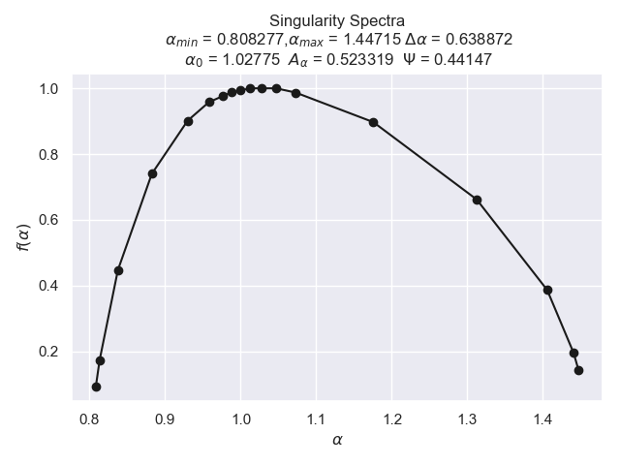

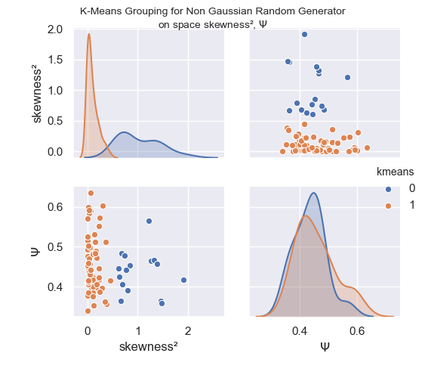

### Colored Noise Generator

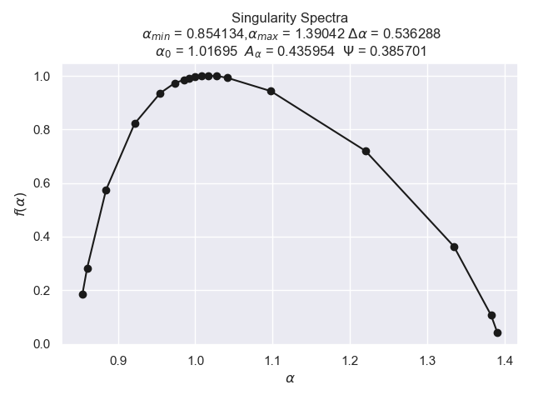

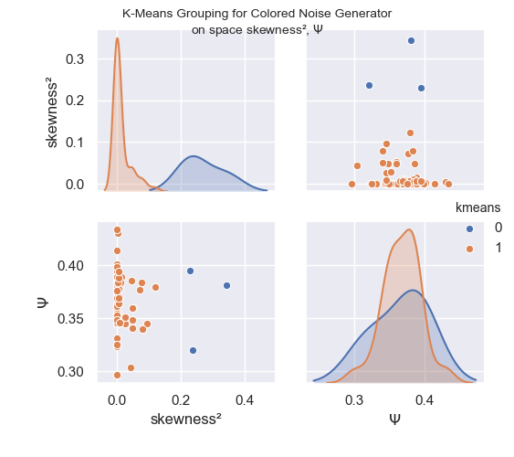

### P-Model

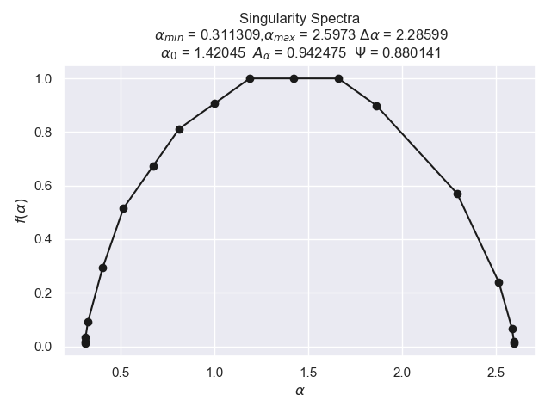

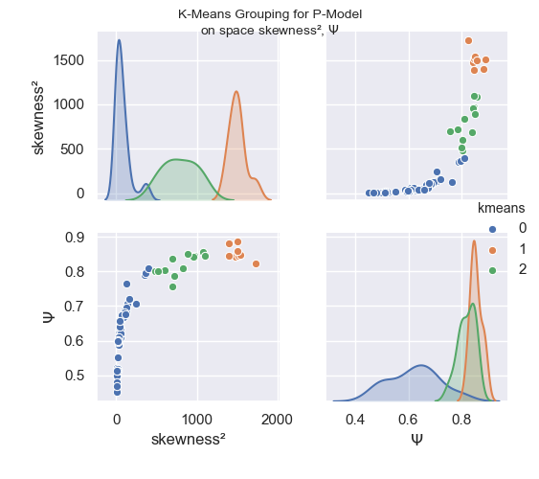

### Logistic Map

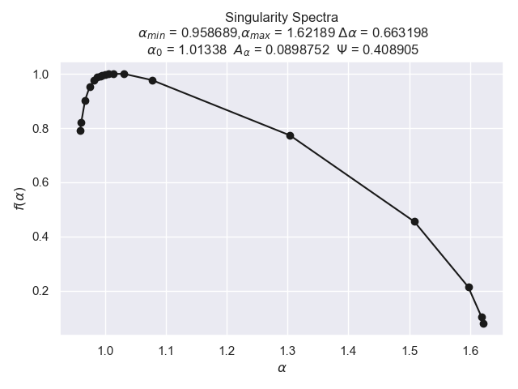

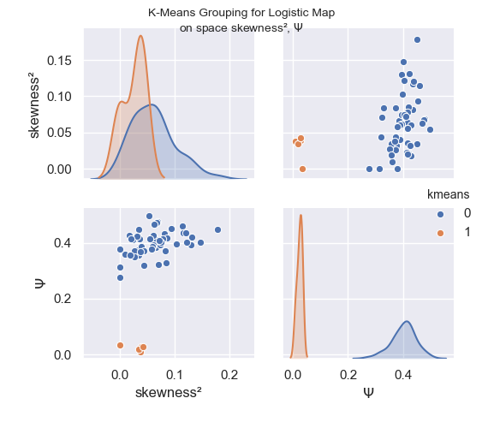

### Henon Map

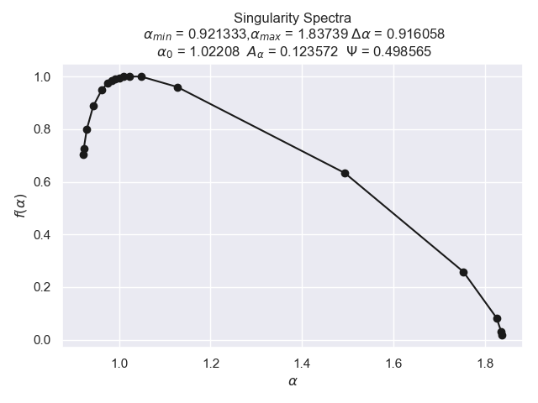

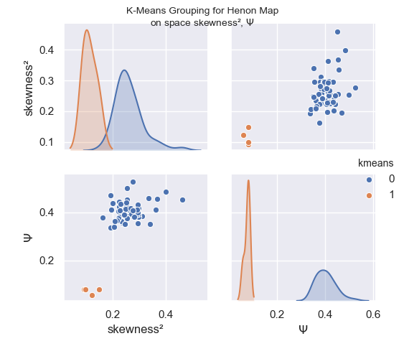

### For all generators:

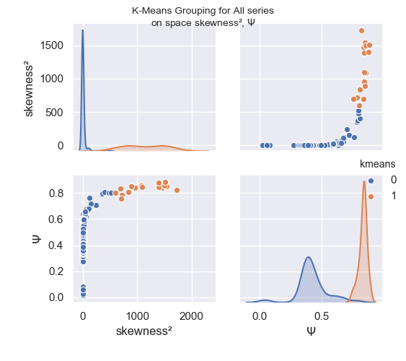

#### Comparing singularity Spectra

Here we show a comparative example of the singularity spectrum for time series generated from different methods, in particular, we see the much wider spectrum of the series generated with P-Model, which is also quite symmetrical, while for the other models, the spectrum is left-truncated, which indicates that the spectrum is insensitive to larger local fluctuations.

The spectrum of the P-Model being the widest, also indicates a higher degree of multifractality and data complexity.

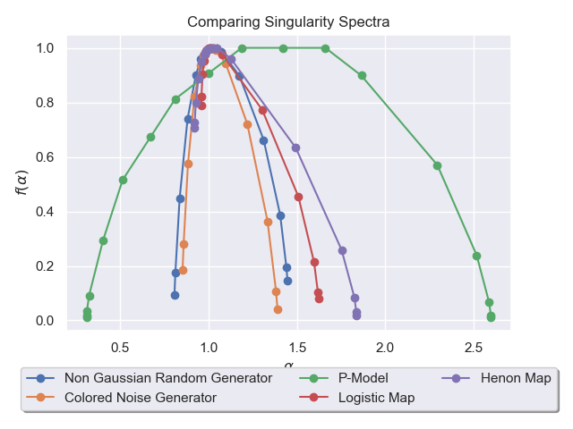

### Exercise 7.3

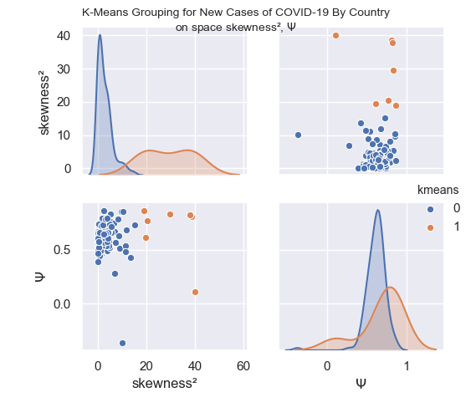

Now, we print the results for each country along with the grouping proposed:

skewness² $\Psi$ Country kmeans group  
0 4.647446 0.575178 Togo 0 0  
0 0.202633 0.710258 Singapore 0 0  
0 0.072929 0.625765 Algeria 0 0  
0 2.543750 0.627909 Macedonia 0 0  
0 0.467714 0.627345 Pakistan 0 0  
0 1.325827 0.637944 Uruguay 0 0  
0 1.321560 0.580162 France 0 0  
0 3.654967 0.757263 Sudan 0 0  
0 3.886317 0.491071 Cameroon 0 0  
0 3.879811 0.567976 Myanmar 0 0  
0 3.659337 0.651311 Georgia 0 0  
0 0.444545 0.667313 Peru 0 0  
0 2.492821 0.539468 Chile 0 0  
0 9.706140 0.851750 China 0 0  
0 3.594521 0.642471 Montenegro 0 0  
0 1.167060 0.701570 Kuwait 0 0  
0 0.333079 0.508259 Slovenia 0 0  
0 0.413701 0.526043 Cote d'Ivoire 0 0  
0 0.957196 0.580388 Bulgaria 0 0  
0 1.980367 0.794184 South Korea 0 0  
0 4.116856 0.648965 Kosovo 0 0  
0 0.652697 0.610987 Costa Rica 0 0  
0 5.630992 0.681193 Jersey 0 0  
0 0.580288 0.698615 Somalia 0 0  
0 4.355623 0.667162 Guam 0 0  
0 4.367243 0.601864 Sierra Leone 0 0  
0 10.334728 0.851464 Maldives 0 0  
0 1.908388 0.676374 Honduras 0 0  
0 0.384417 0.717378 Tajikistan 0 0  
0 8.972552 0.516844 Syria 0 0  
0 2.092928 0.680727 Oman 0 0  
0 0.000673 0.736029 United Arab Emirates 0 0  
0 0.297407 0.493998 Albania 0 0  
0 11.290277 0.537318 Venezuela 0 0  
0 0.152061 0.626064 Canada 0 0  
0 1.042293 0.471629 Puerto Rico 0 0  
0 15.116490 0.728573 South Sudan 0 0  
0 1.015743 0.683595 Egypt 0 0  
0 3.834250 0.573255 Yemen 0 0  
0 1.450362 0.687482 Brazil 0 0  
0 0.288073 0.677033 Philippines 0 0  
0 4.721597 0.575959 Haiti 0 0  
0 0.820070 0.578630 Guinea 0 0  
0 1.482140 0.733633 Iceland 0 0  
0 0.510387 0.737690 Nigeria 0 0  
0 0.019167 0.671172 Panama 0 0  
0 1.956095 0.683703 Luxembourg 0 0  
0 0.422834 0.561843 Qatar 0 0  
0 5.814925 0.697598 Swaziland 0 0  
0 1.316442 0.724524 Andorra 0 0  
0 1.702694 0.647212 Greece 0 0  
0 10.118350 -0.366717 Mauritania 0 0  
0 4.510562 0.721361 Chad 0 0  
0 3.604264 0.653150 Gabon 0 0  
0 1.833140 0.569111 Uzbekistan 0 0  
0 1.350167 0.589923 San Marino 0 0  
0 0.289422 0.591646 Cuba 0 0  
0 0.163612 0.525761 Turkey 0 0  
0 0.233458 0.650414 Saudi Arabia 0 0  
0 11.946241 0.680367 Bermuda 0 0  
0 5.361762 0.754220 Mauritius 0 0  
0 0.156166 0.456439 Netherlands 0 0  
0 38.705327 0.811326 Ecuador 1 1  
0 7.133255 0.666112 Isle of Man 0 0  
0 4.945854 0.518206 Brunei 0 0  
0 8.648913 0.626472 Ethiopia 0 0  
0 3.754995 0.617199 Jamaica 0 0  
0 2.815139 0.685874 Austria 0 0  
0 4.542406 0.666447 Democratic Republic of Congo 0 0  
0 2.468764 0.859518 Iran 0 0  
0 0.057677 0.549989 Moldova 0 0  
0 0.774652 0.635916 Switzerland 0 0  
0 0.866226 0.599805 Portugal 0 0  
0 3.981207 0.616590 Latvia 0 0  
0 5.556237 0.714938 Djibouti 0 0  
0 5.294765 0.834002 Australia 0 0  
0 5.410535 0.758939 Cape Verde 0 0  
0 6.675924 0.742956 Ghana 0 0  
0 5.485914 0.660766 Mozambique 0 0  
0 2.175084 0.730597 Tunisia 0 0  
0 0.647029 0.651793 Germany 0 0  
0 4.520122 0.534822 Guatemala 0 0  
0 1.465938 0.643236 Kyrgyzstan 0 0  
0 1.013826 0.661524 Jordan 0 0  
0 1.281123 0.628203 Norway 0 0  
0 6.909623 0.280093 Gibraltar 0 0  
0 3.901946 0.622955 Lebanon 0 0  
0 1.467173 0.454918 Liberia 0 0  
0 0.892830 0.506856 Denmark 0 0  
0 0.039245 0.457992 United Kingdom 0 0  
0 4.929983 0.737329 Central African Republic 0 0  
0 3.300508 0.784136 Guinea-Bissau 0 0  
0 0.037626 0.508038 Sweden 0 0  
0 3.491879 0.540031 Afghanistan 0 0  
0 3.983541 0.789059 Thailand 0 0  
0 1.923195 0.633786 Cyprus 0 0  
0 1.830543 0.537495 Czech Republic 0 0  
0 0.764101 0.643495 Bahrain 0 0  
0 7.307871 0.568489 Madagascar 0 0  
0 3.022034 0.604260 Guernsey 0 0  
0 2.450815 0.567459 Argentina 0 0  
0 19.580510 0.616237 Uganda 1 1  
0 1.190708 0.472973 World 0 0  
0 4.451831 0.664844 Vietnam 0 0  
0 0.101384 0.549911 Italy 0 0  
0 0.057654 0.578791 Russia 0 0  
0 0.655120 0.628969 Belgium 0 0  
0 0.616365 0.440806 Indonesia 0 0  
0 1.171850 0.488924 Azerbaijan 0 0  
0 0.189069 0.541051 Poland 0 0  
0 40.198014 0.110913 Faeroe Islands 1 1  
0 2.765333 0.644367 Rwanda 0 0  
0 4.117660 0.679231 Slovakia 0 0  
0 0.284641 0.532925 Dominican Republic 0 0  
0 0.000745 0.392374 Romania 0 0  
0 3.802329 0.575879 Congo 0 0  
0 0.682732 0.663019 Spain 0 0  
0 11.542053 0.482232 Sri Lanka 0 0  
0 4.121991 0.659845 Malta 0 0  
0 2.521892 0.613528 Hungary 0 0  
0 0.510143 0.524642 Bosnia and Herzegovina 0 0  
0 29.636860 0.831022 Tanzania 1 1  
0 1.601927 0.636455 Burkina Faso 0 0  
0 4.150665 0.607538 Niger 0 0  
0 3.223909 0.651846 Iraq 0 0  
0 0.963184 0.663438 El Salvador 0 0  
0 0.981396 0.626315 India 0 0  
0 5.566954 0.718571 Japan 0 0  
0 0.208241 0.470028 Malaysia 0 0  
0 37.822406 0.821231 Palestine 1 1  
0 8.233686 0.785995 Equatorial Guinea 0 0  
0 0.002463 0.603193 Ukraine 0 0  
0 13.622762 0.428247 Zambia 0 0  
0 18.925393 0.865696 Sao Tome and Principe 1 1  
0 0.611815 0.664263 Mali 0 0  
0 0.344648 0.574355 United States 0 0  
0 20.397149 0.766615 Benin 1 1  
0 2.546705 0.647621 Armenia 0 0

## Exercise 8

### Exercise 8.1

Here we compare the Continuous Wavelet Spectrum for time series generated with each signal generator used so far,  
 along with provided data series. Both Morley and DOG wavelet charts are used.

### surftemp504 Dataset

#### Morley:

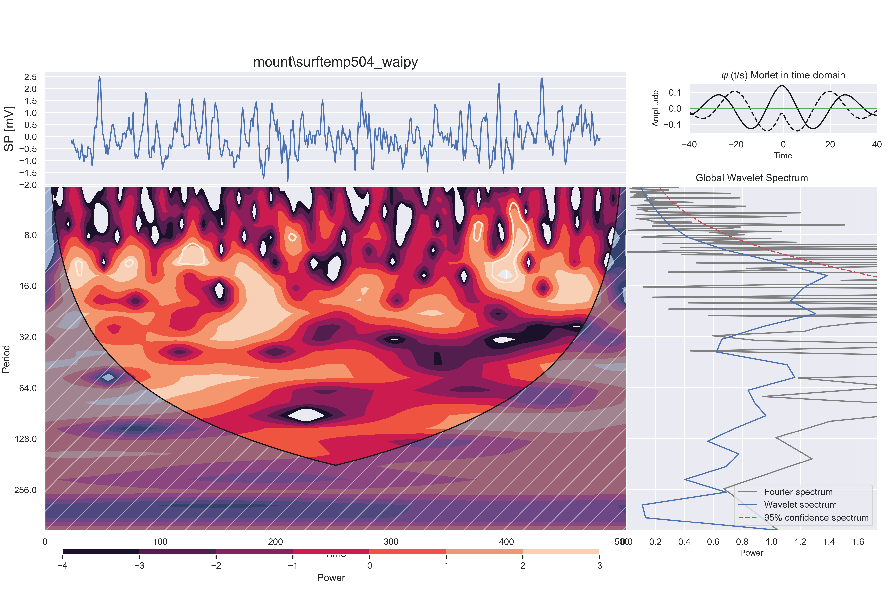

#### DOG:

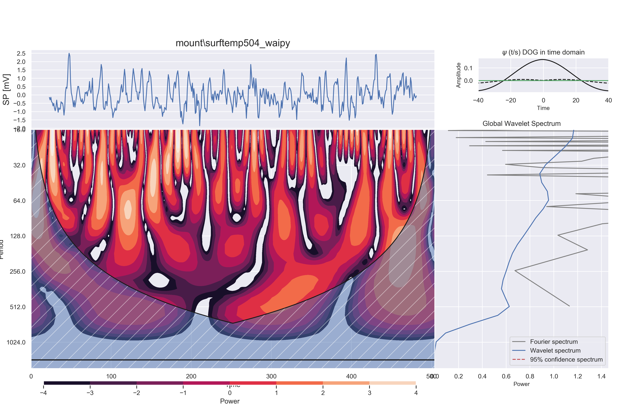

### sol3ghz Dataset

#### Morley:

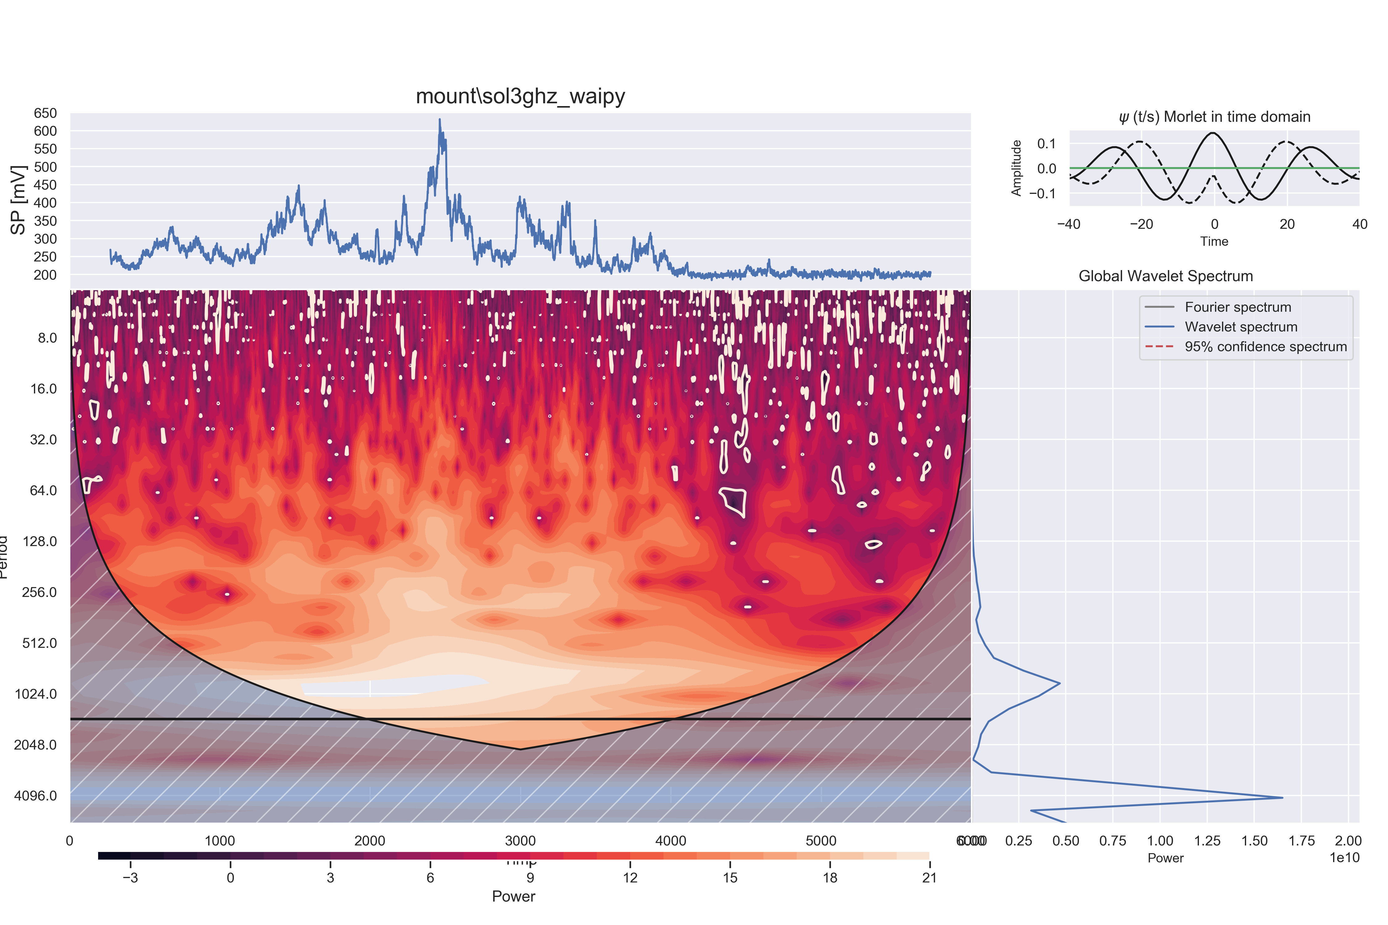

#### DOG:

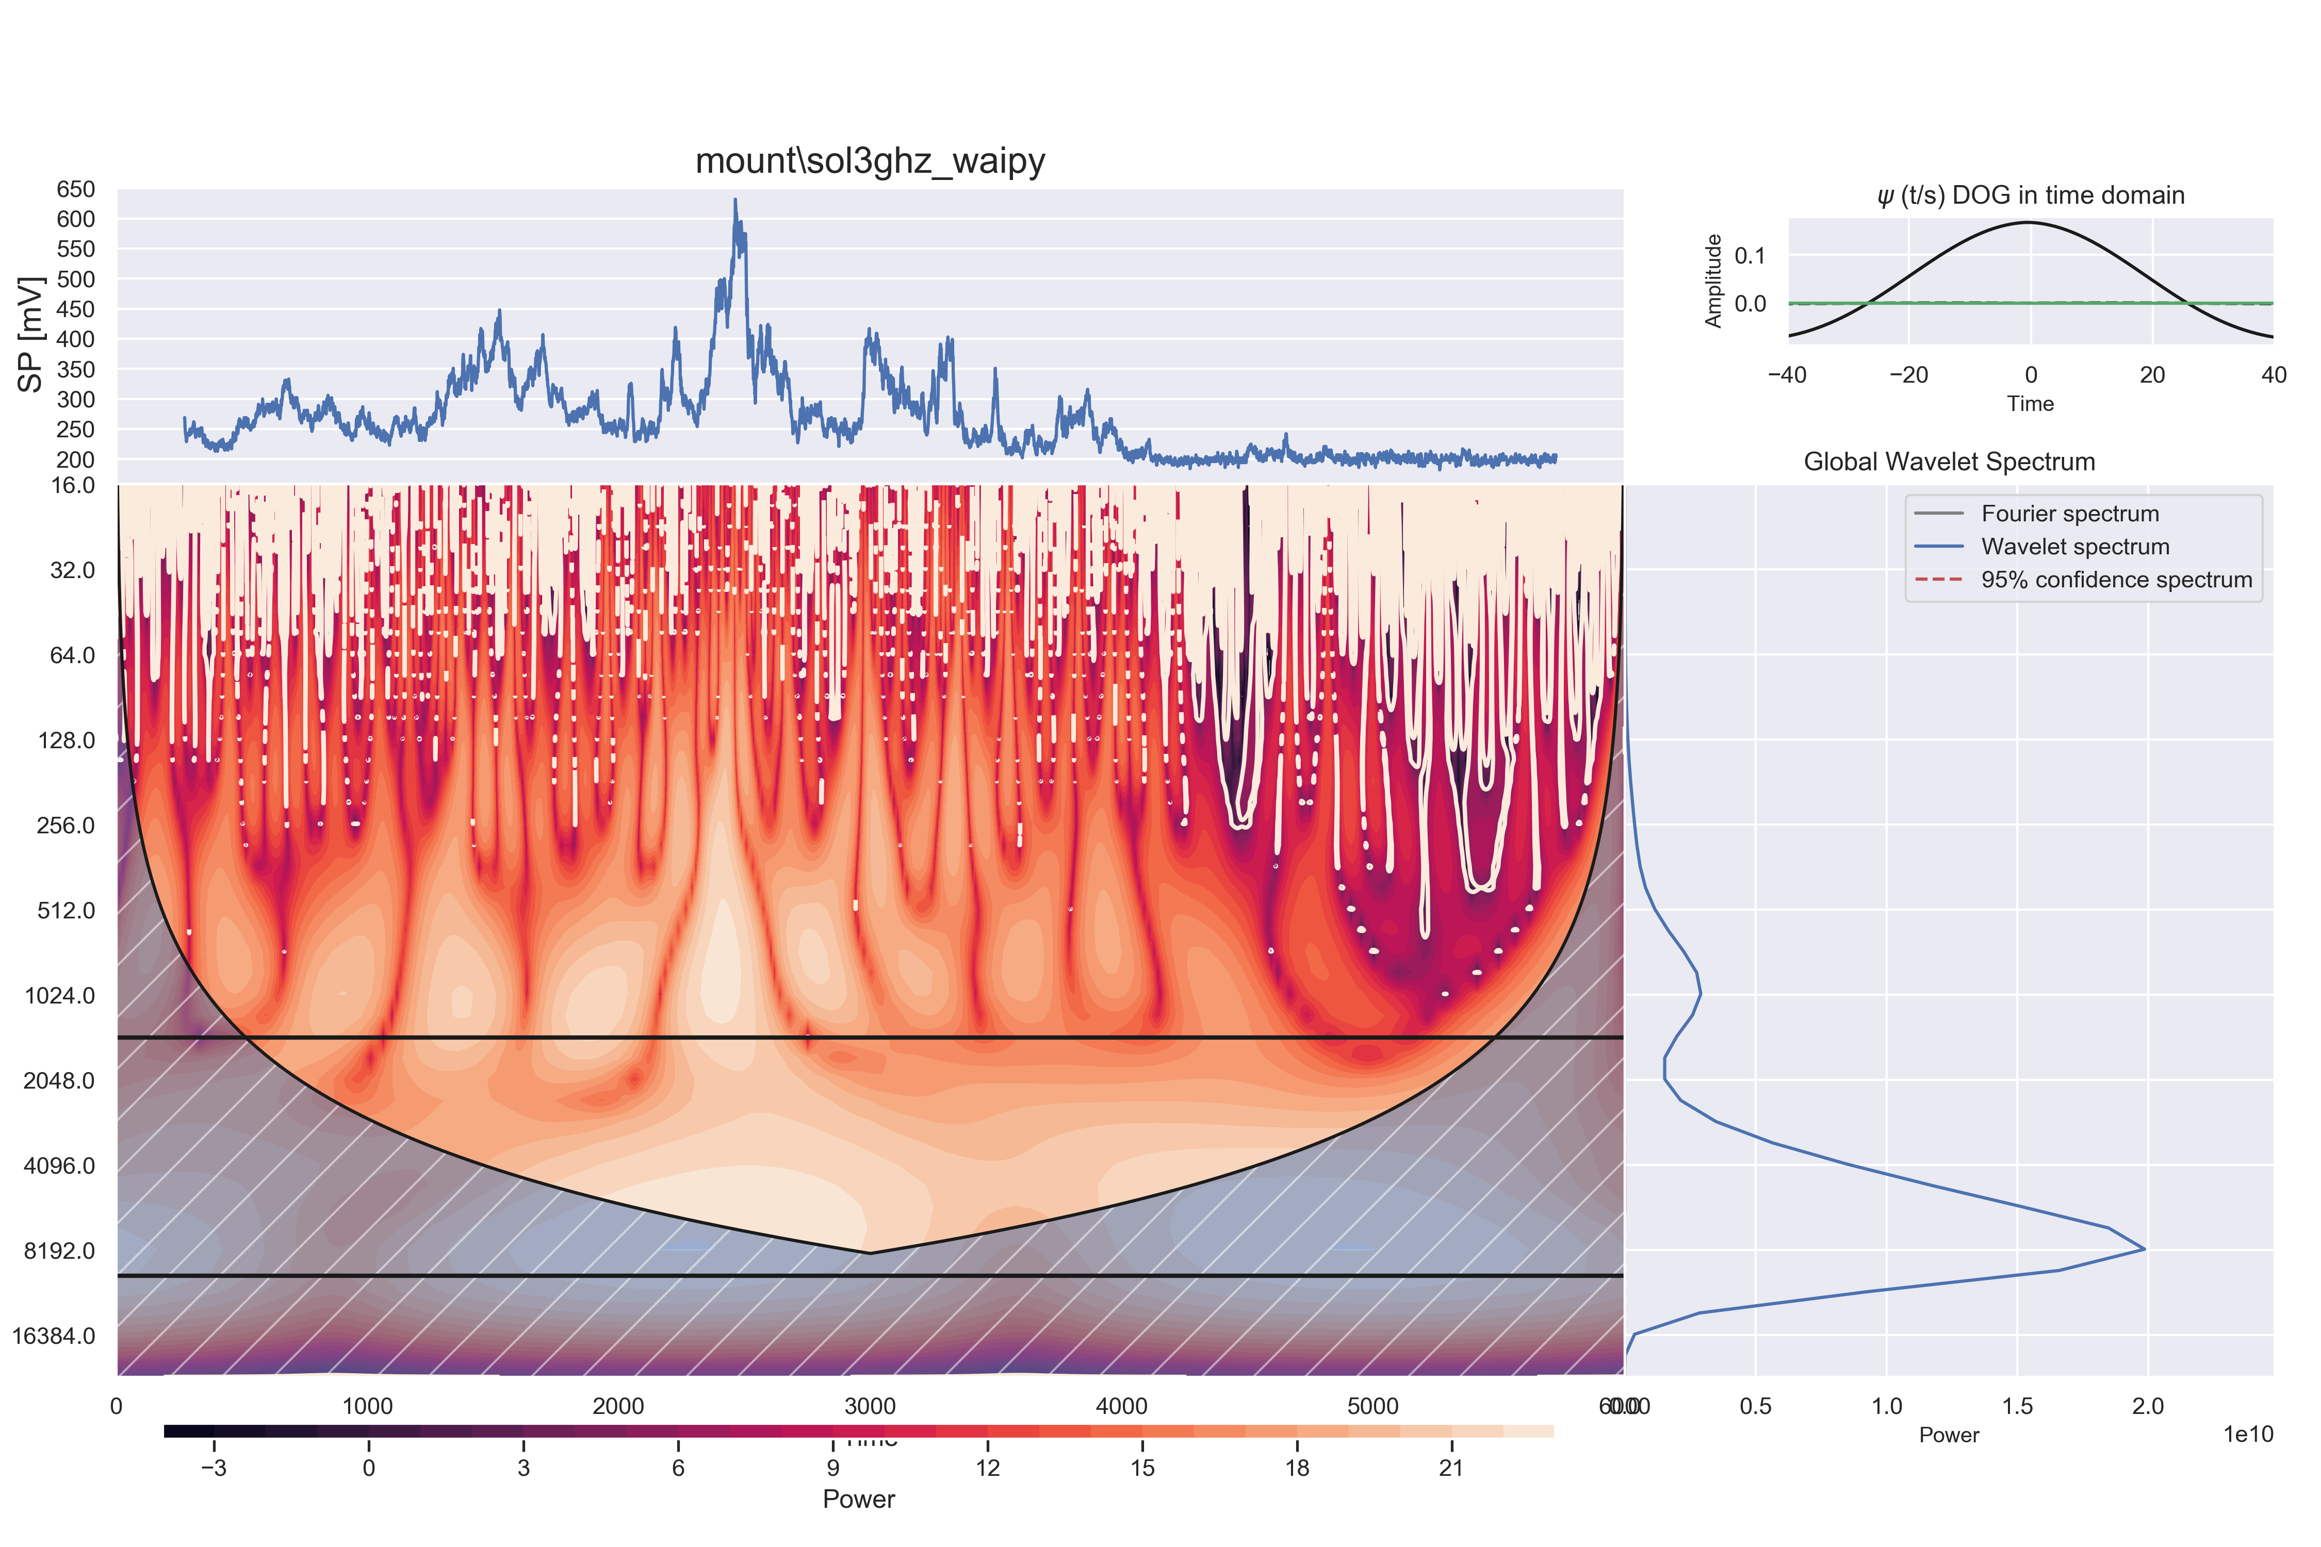

Particularly for sol3ghz data set, we see two wavelet spectrum peaks, which indicates some recurring feature of the signal that occurs in the time associated with around 8000 samples.

### Daily new cases of COVID-19 in the USA

#### Morley:

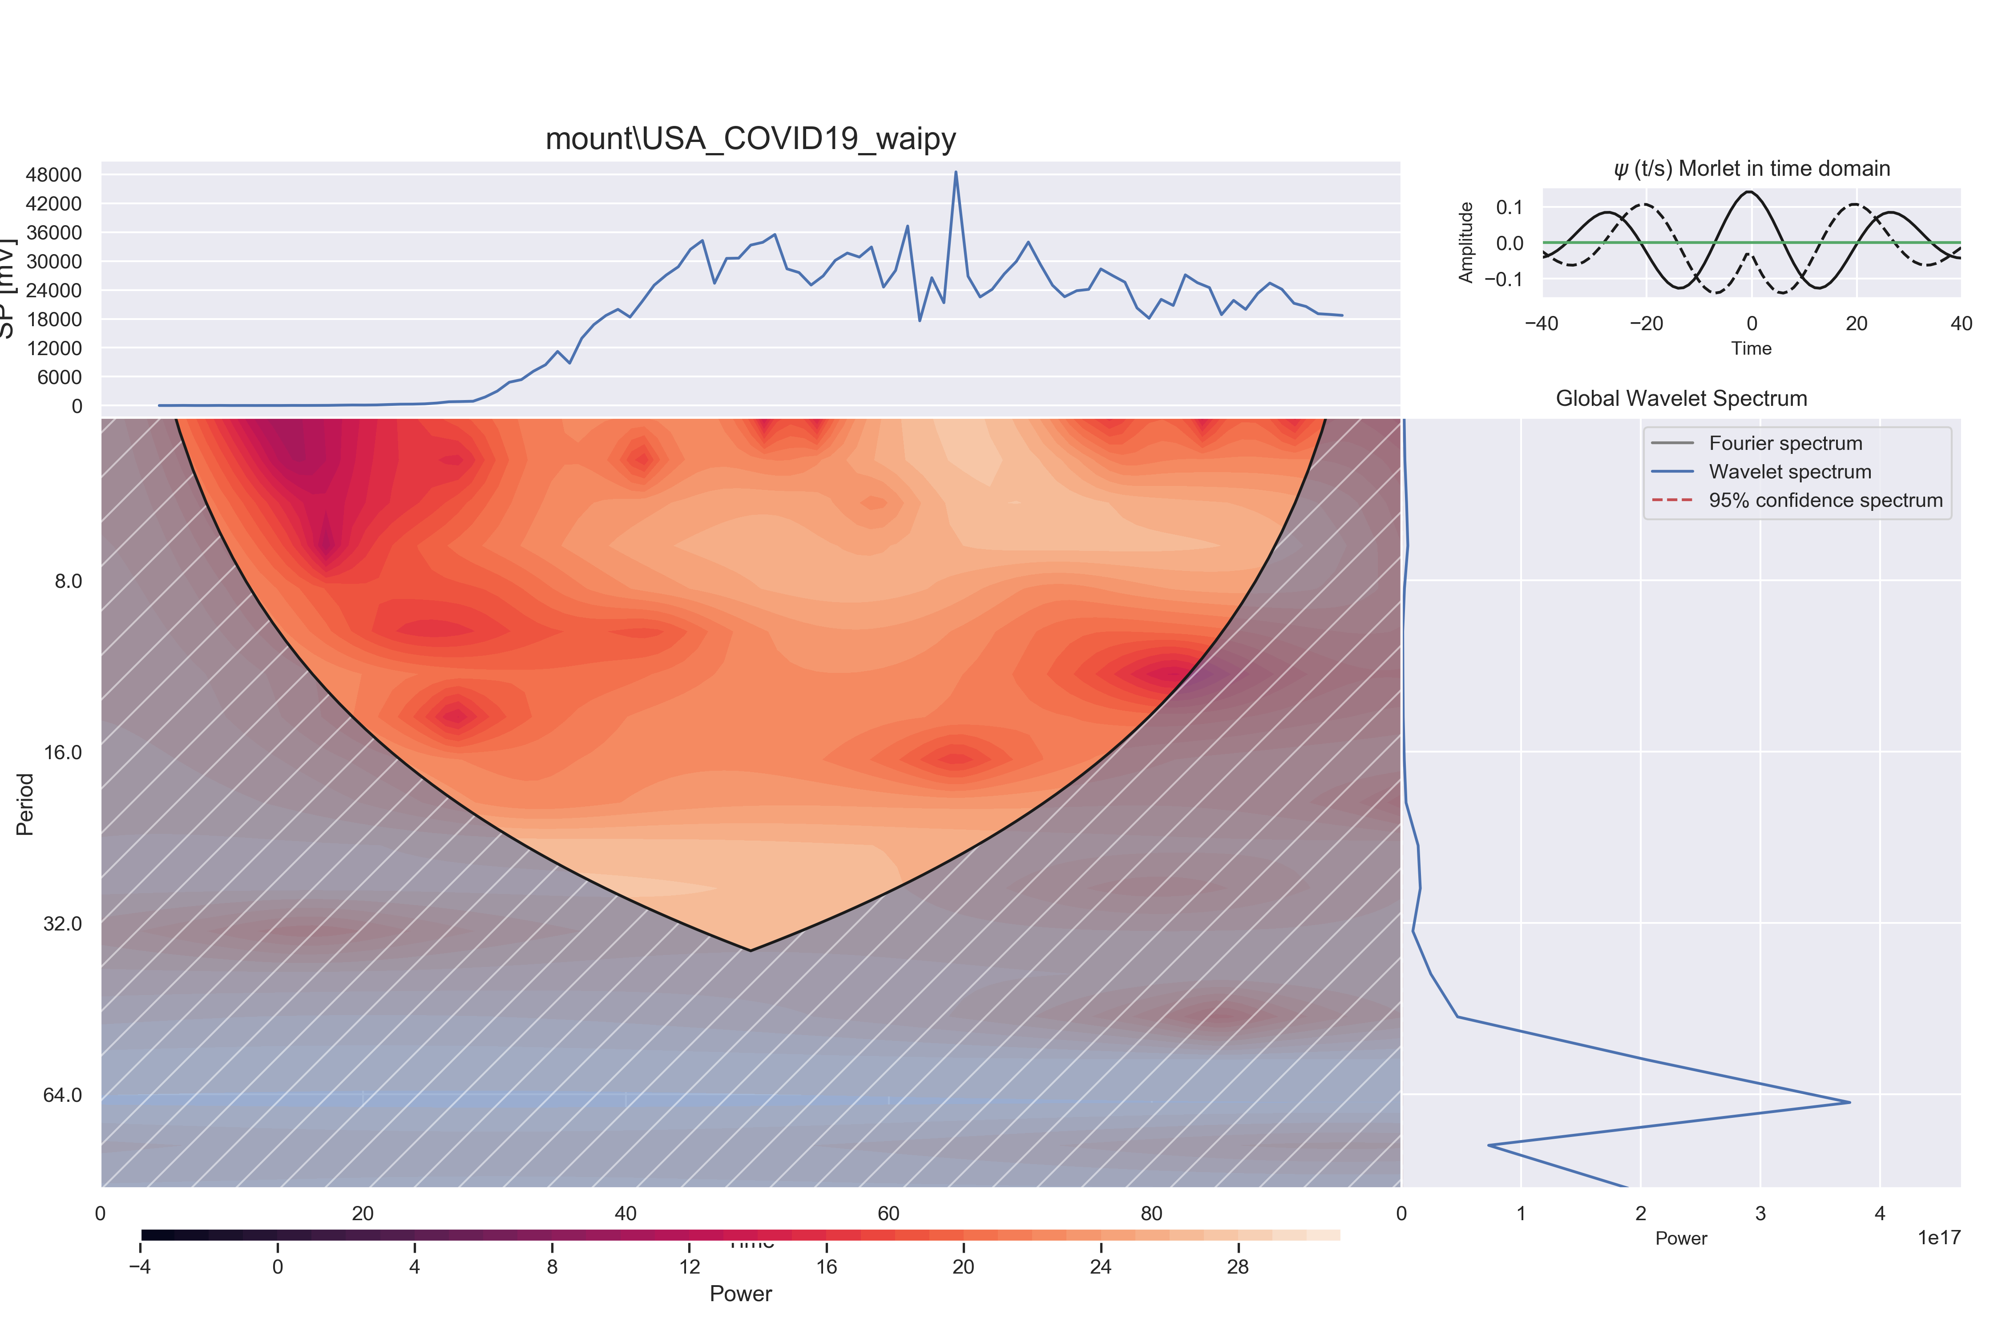

#### DOG:

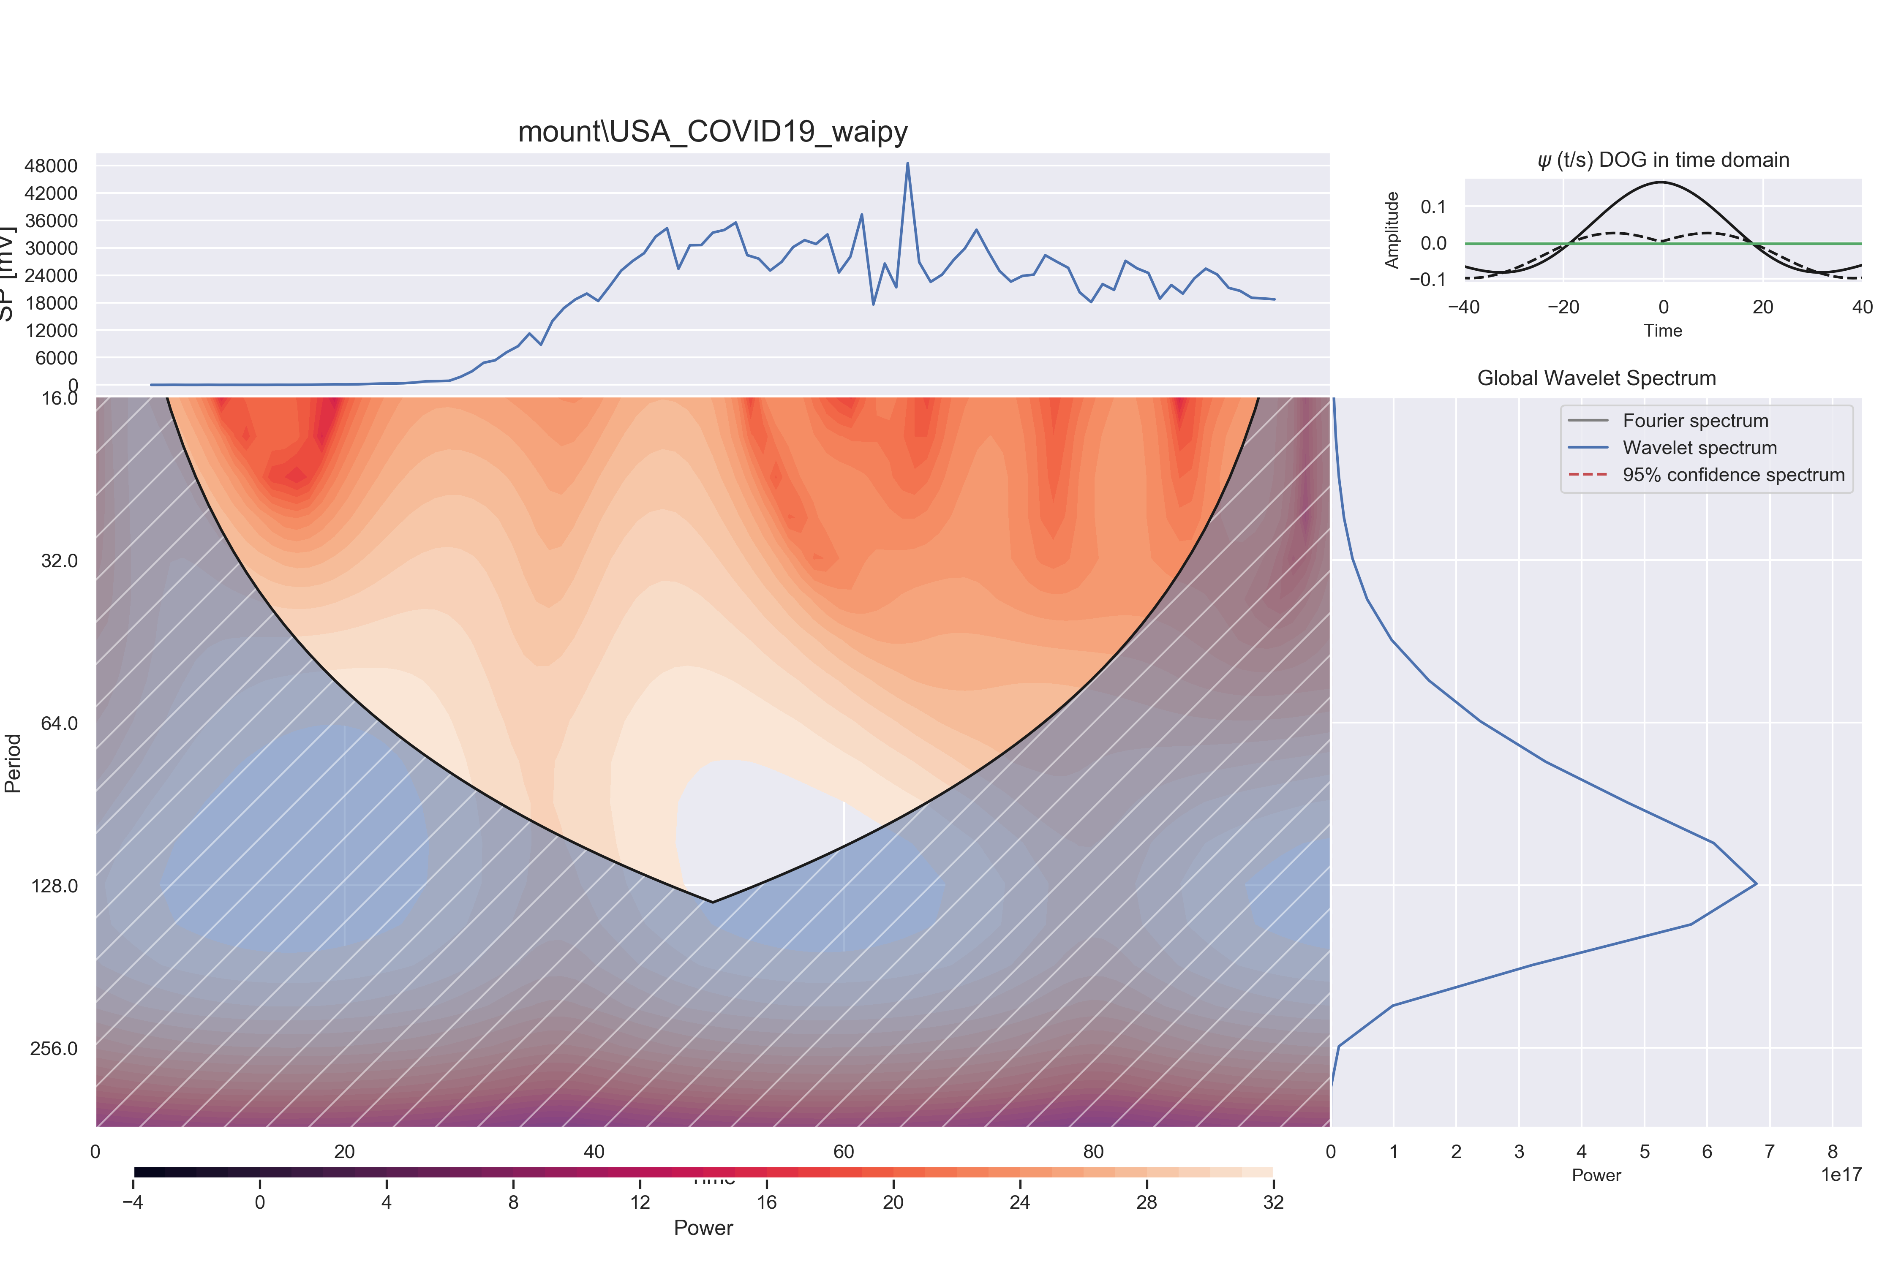

The DOG wavelet seems to reveal some interesting pattern on the USA COVID-19 data around the 128 dayperiod, while the Morlet transform peaks the spectrum close to 64 days.

### Non Gaussian Random Generator

#### Morley:

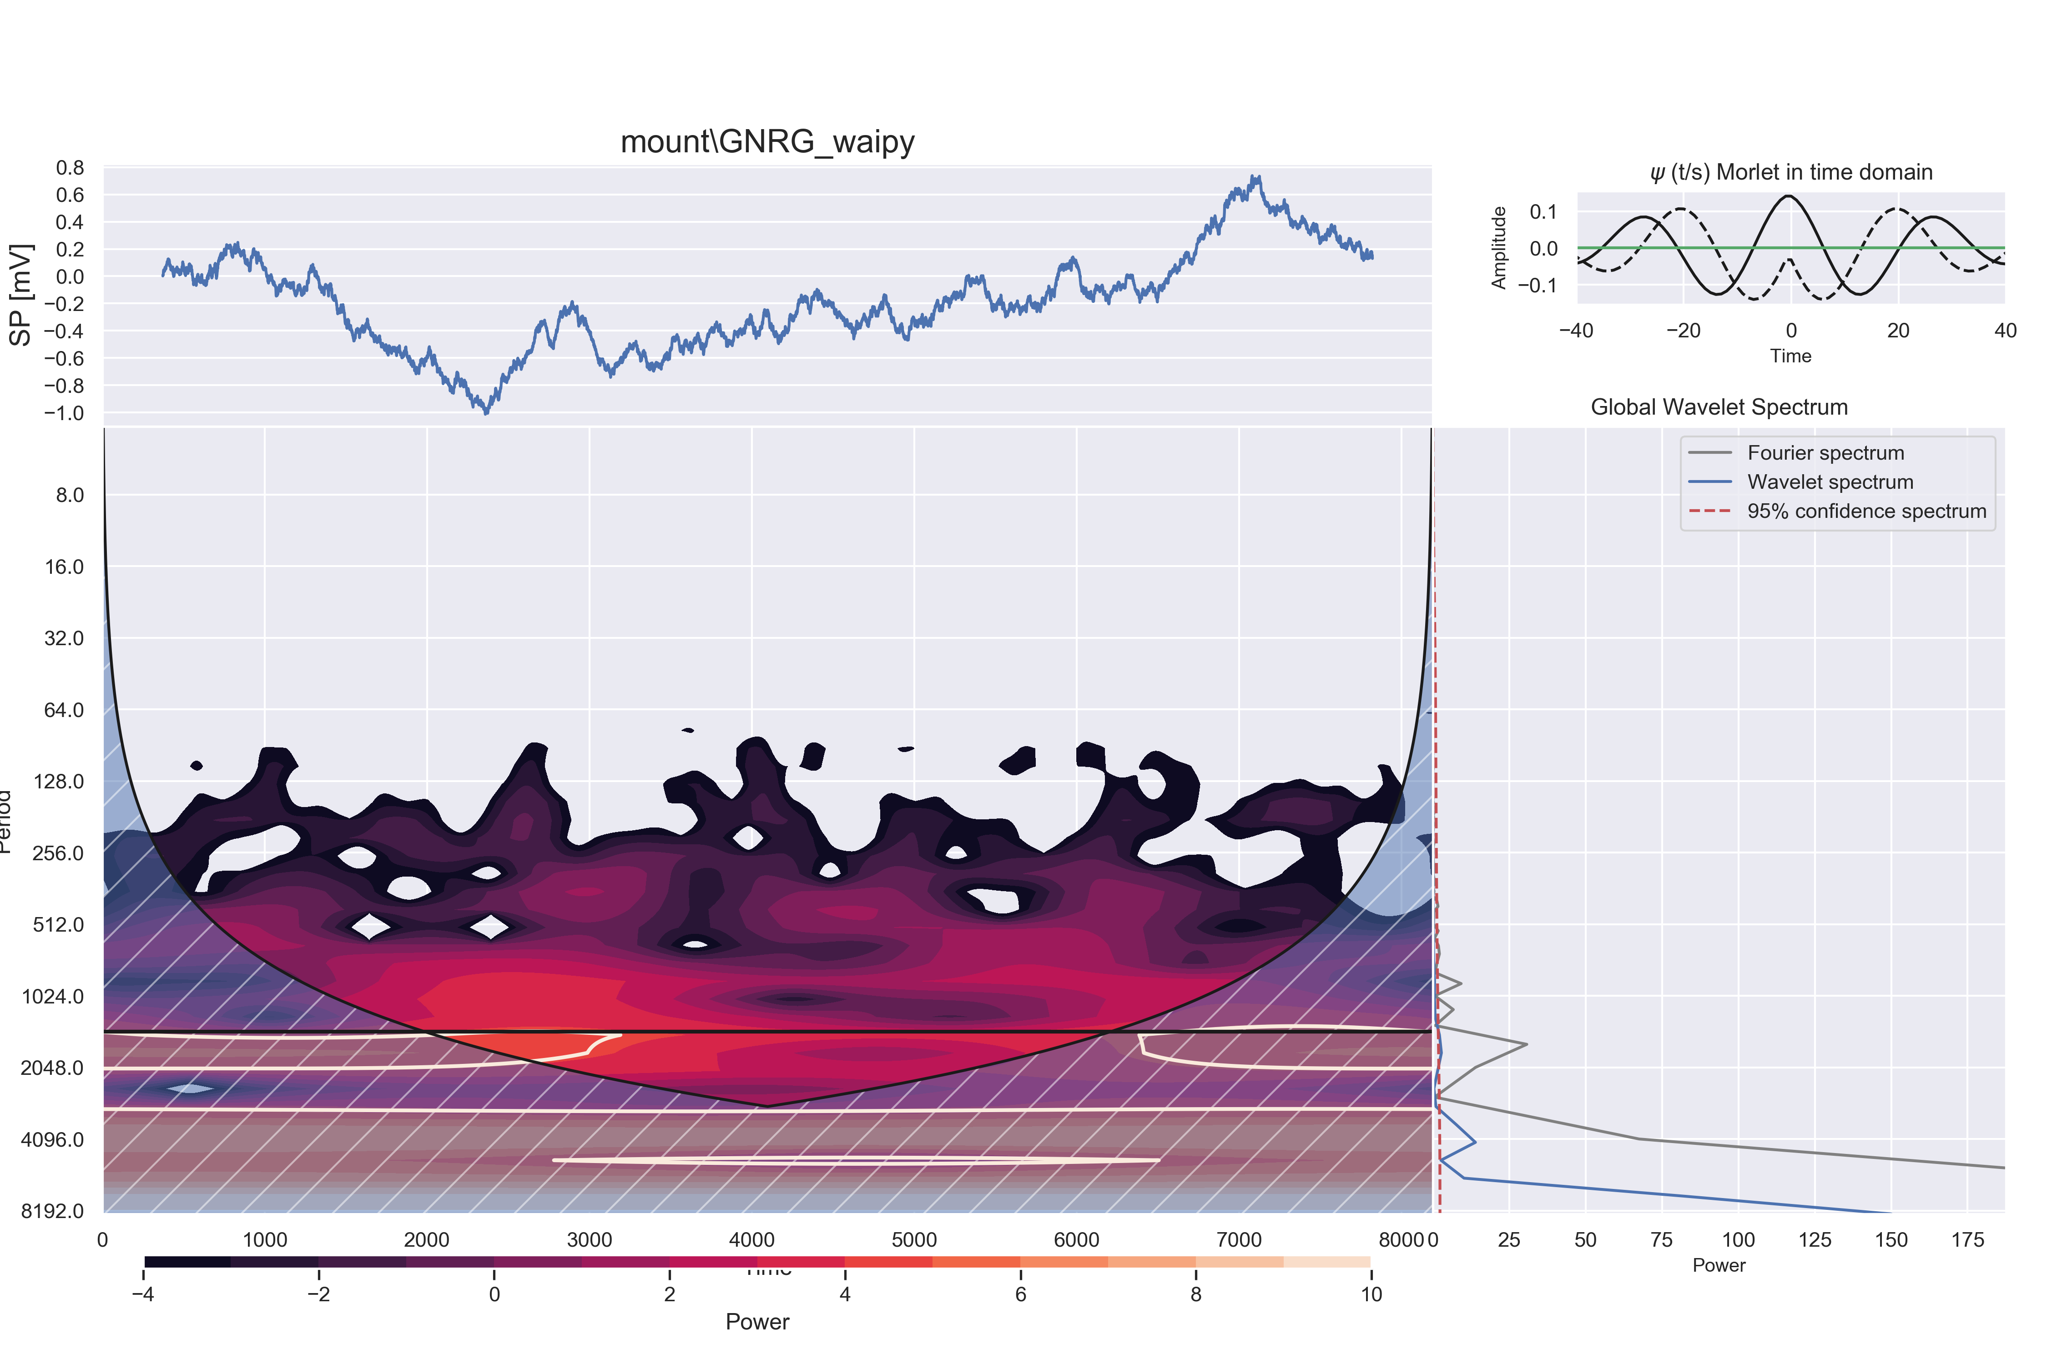

#### DOG:

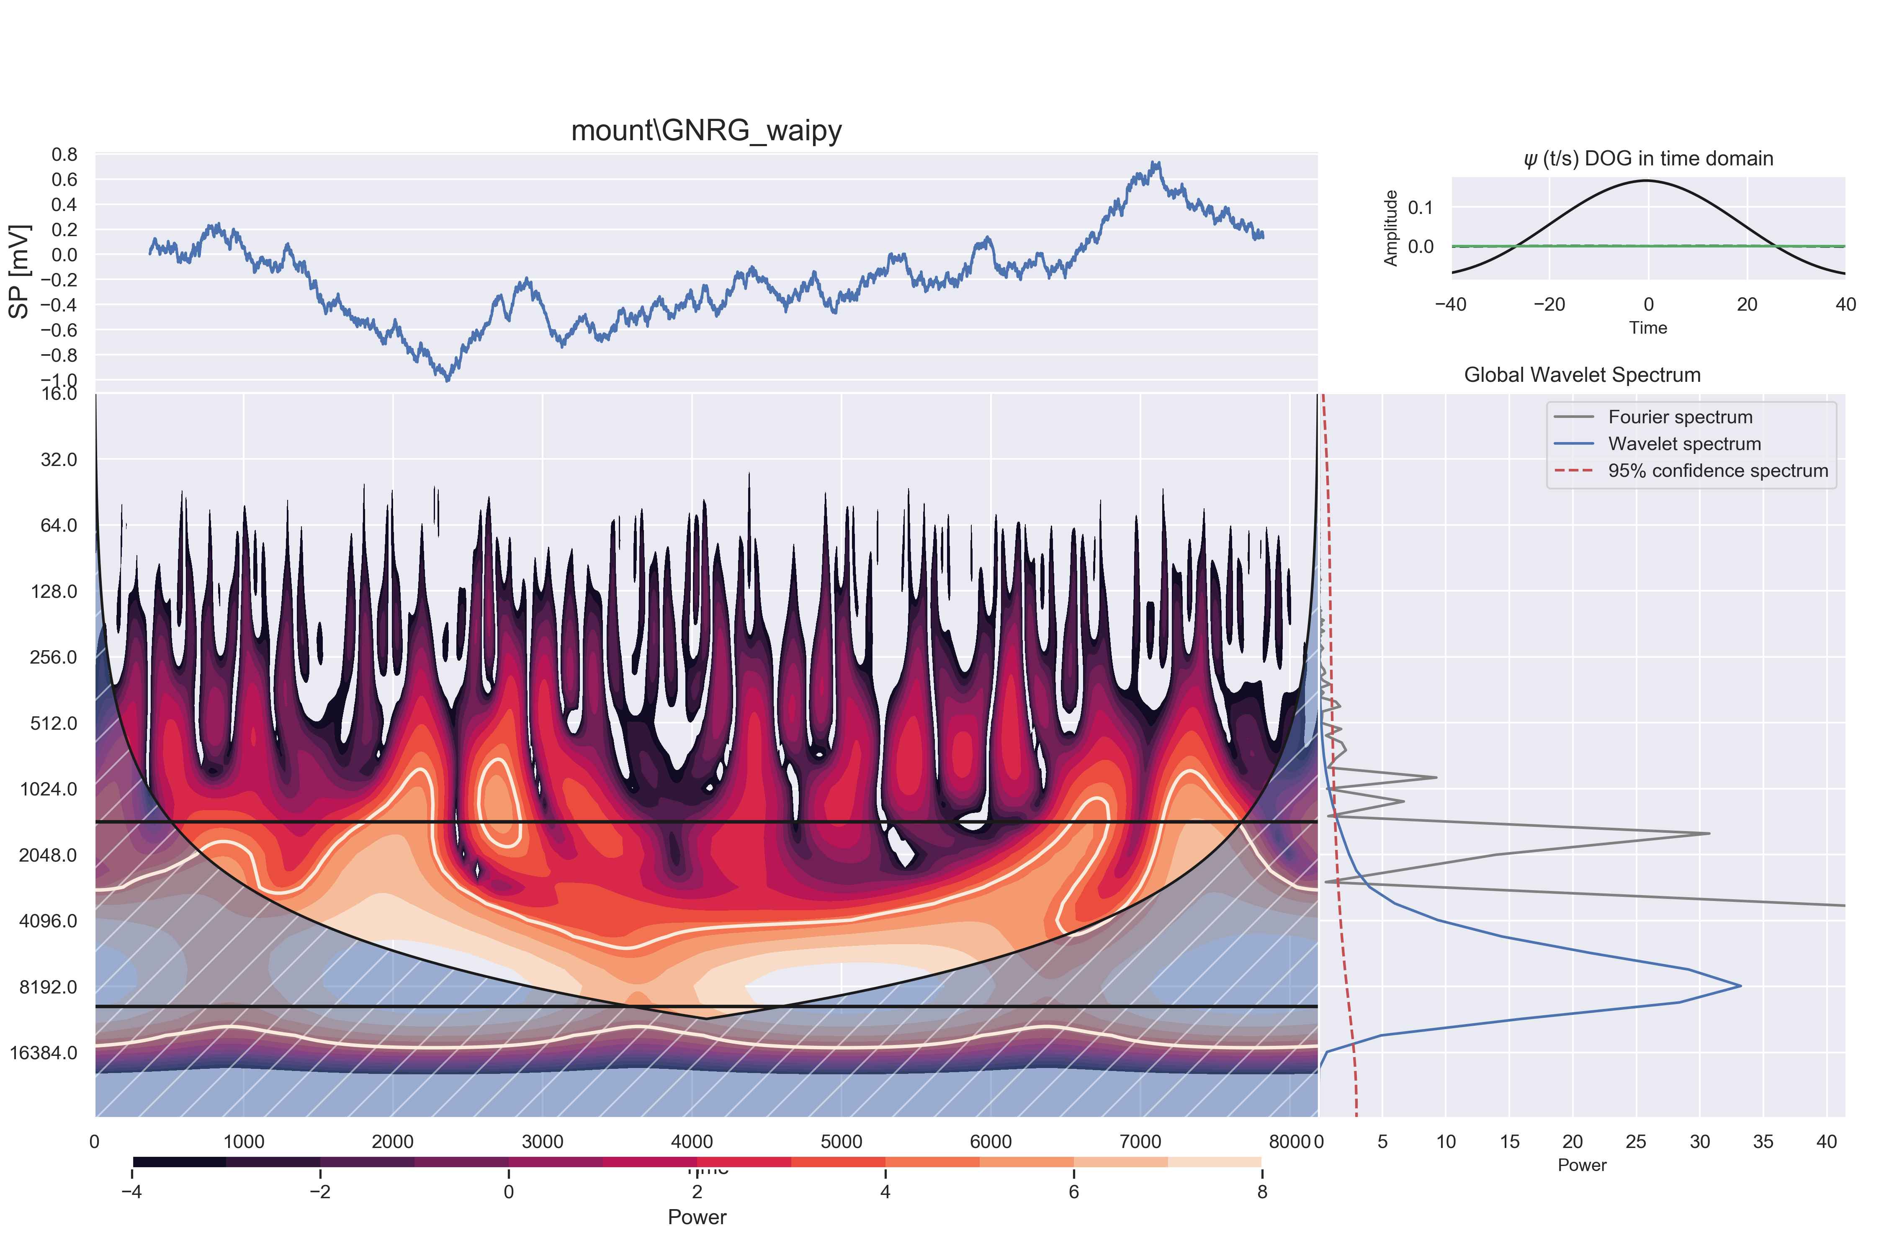

### Colored Noise Generator

#### Morley:

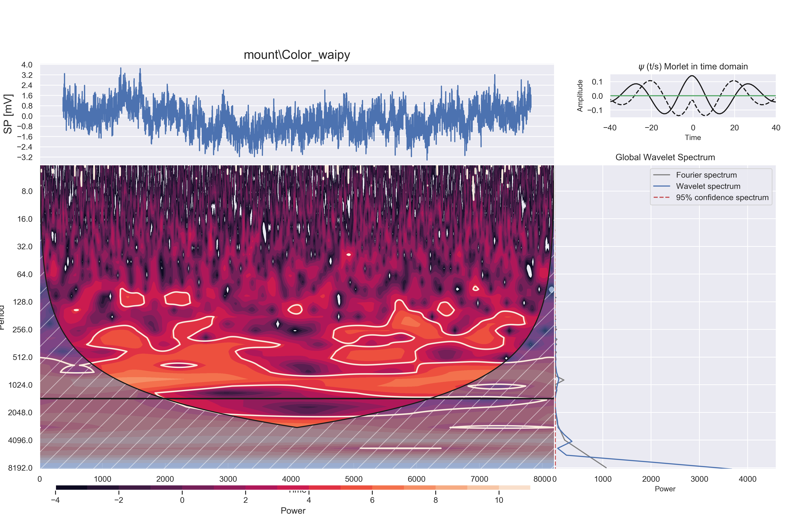

#### DOG:

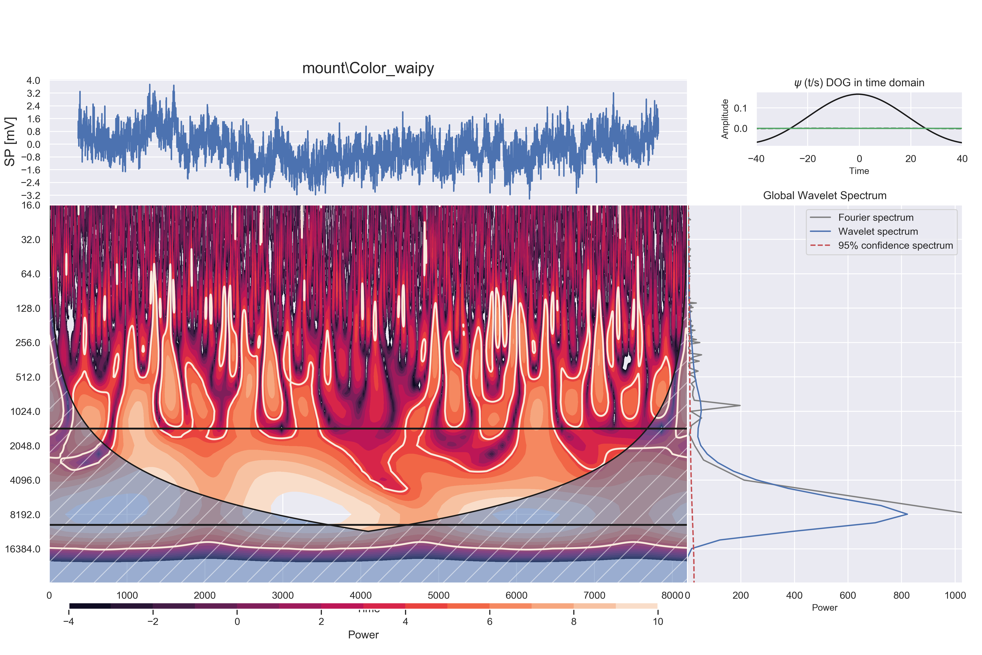

### P-Model Endogenous

#### Morley:

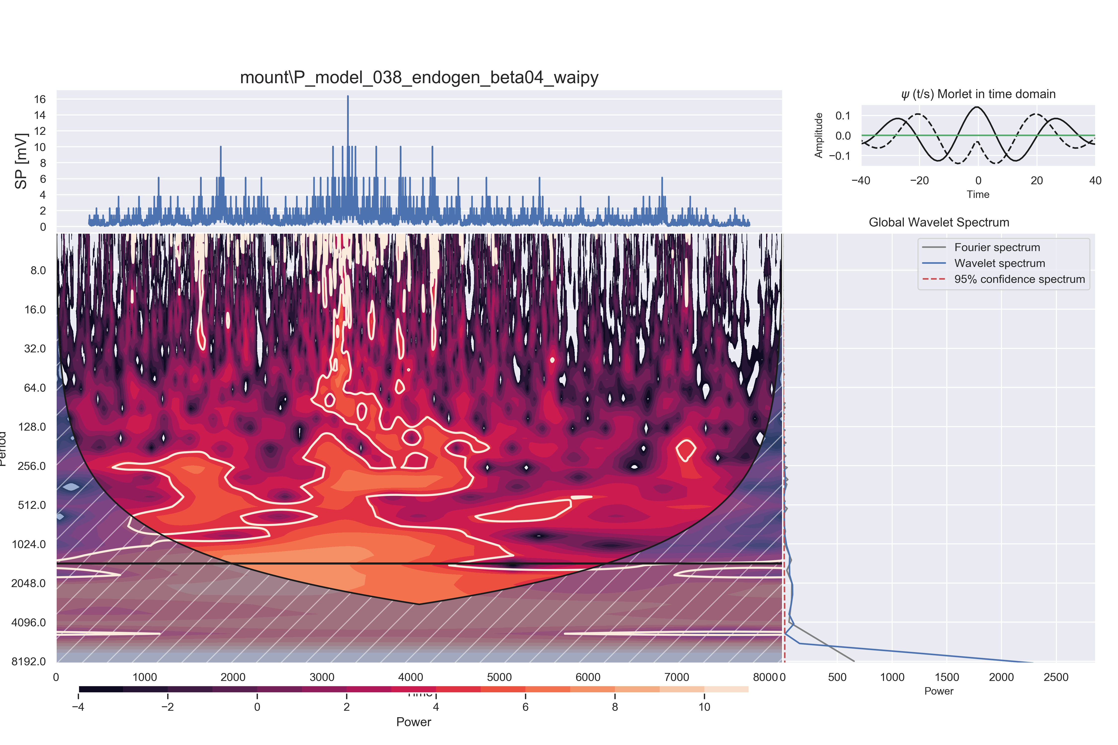

#### DOG:

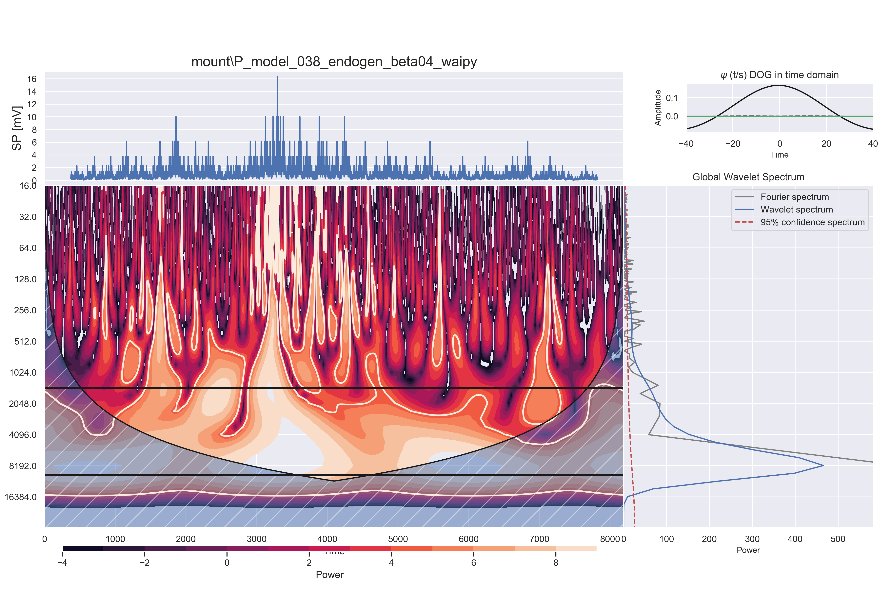

### P-Model Exogenous

#### Morley:

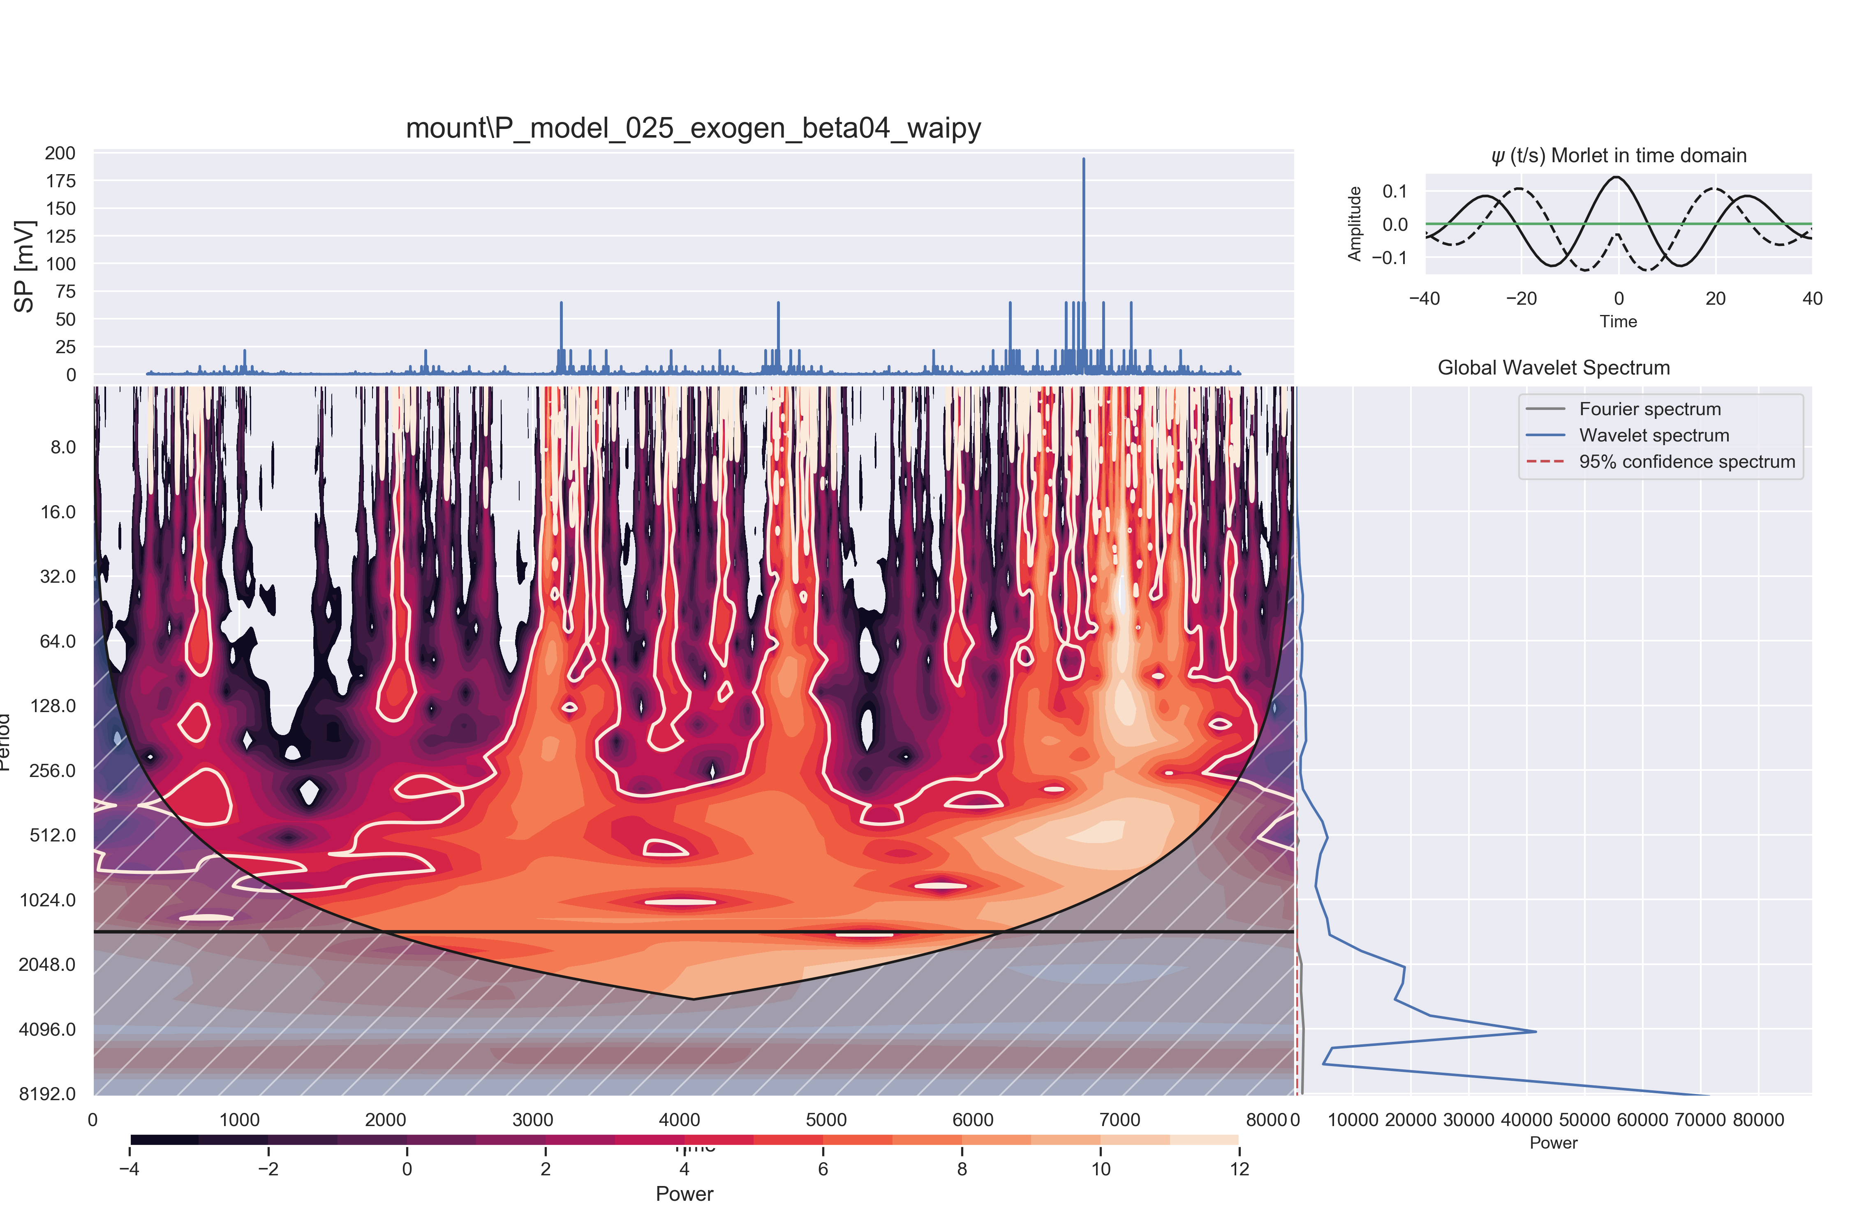

#### DOG:

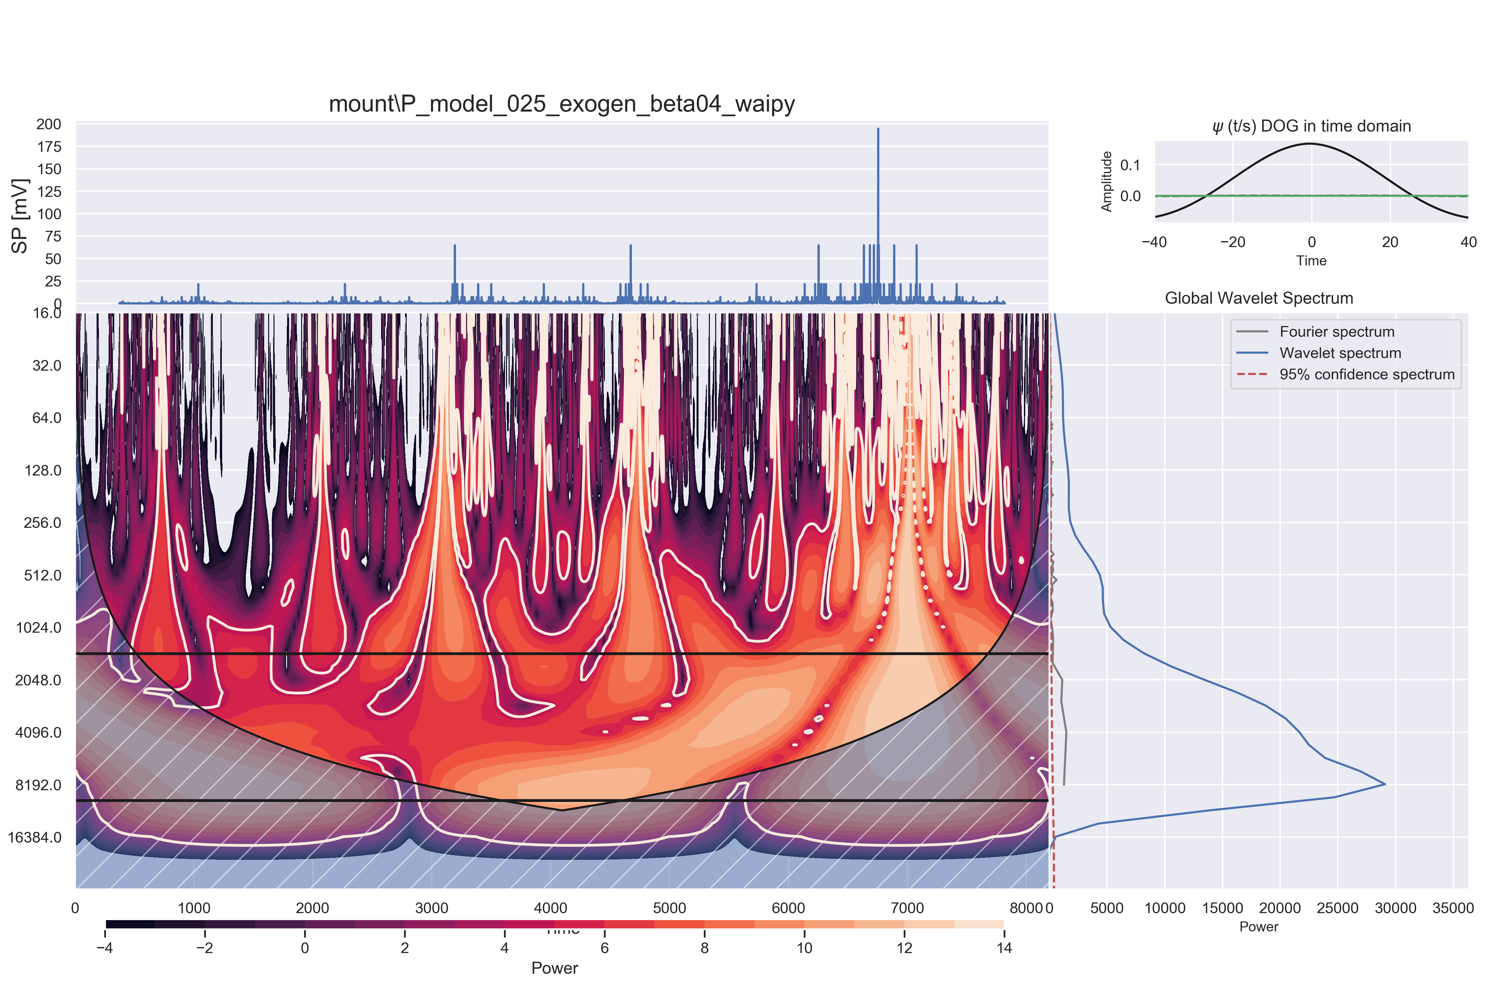

### Logistic Map

#### Morley:

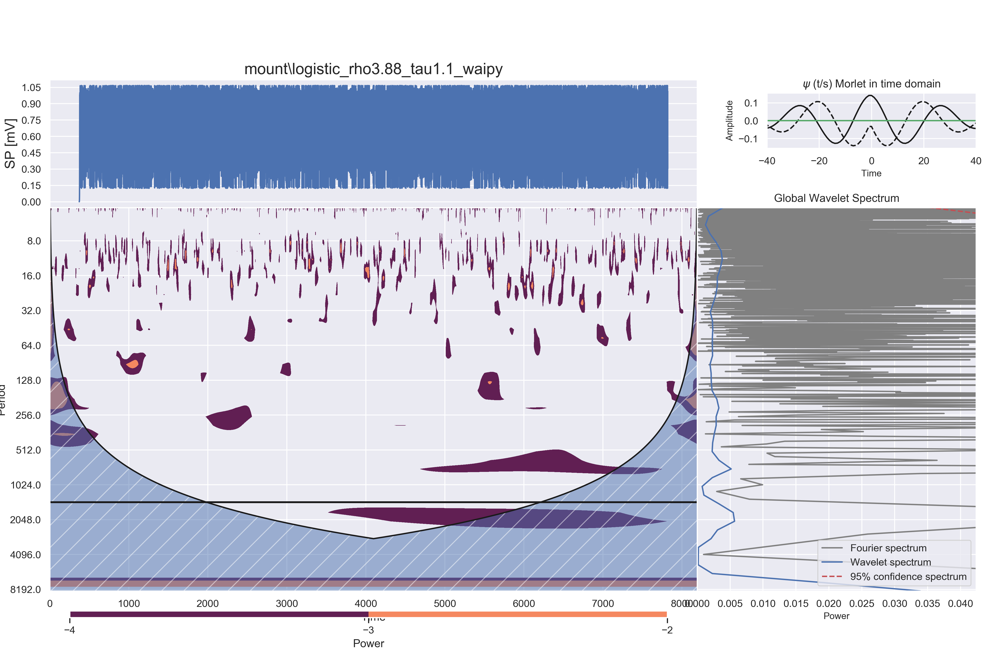

#### DOG:

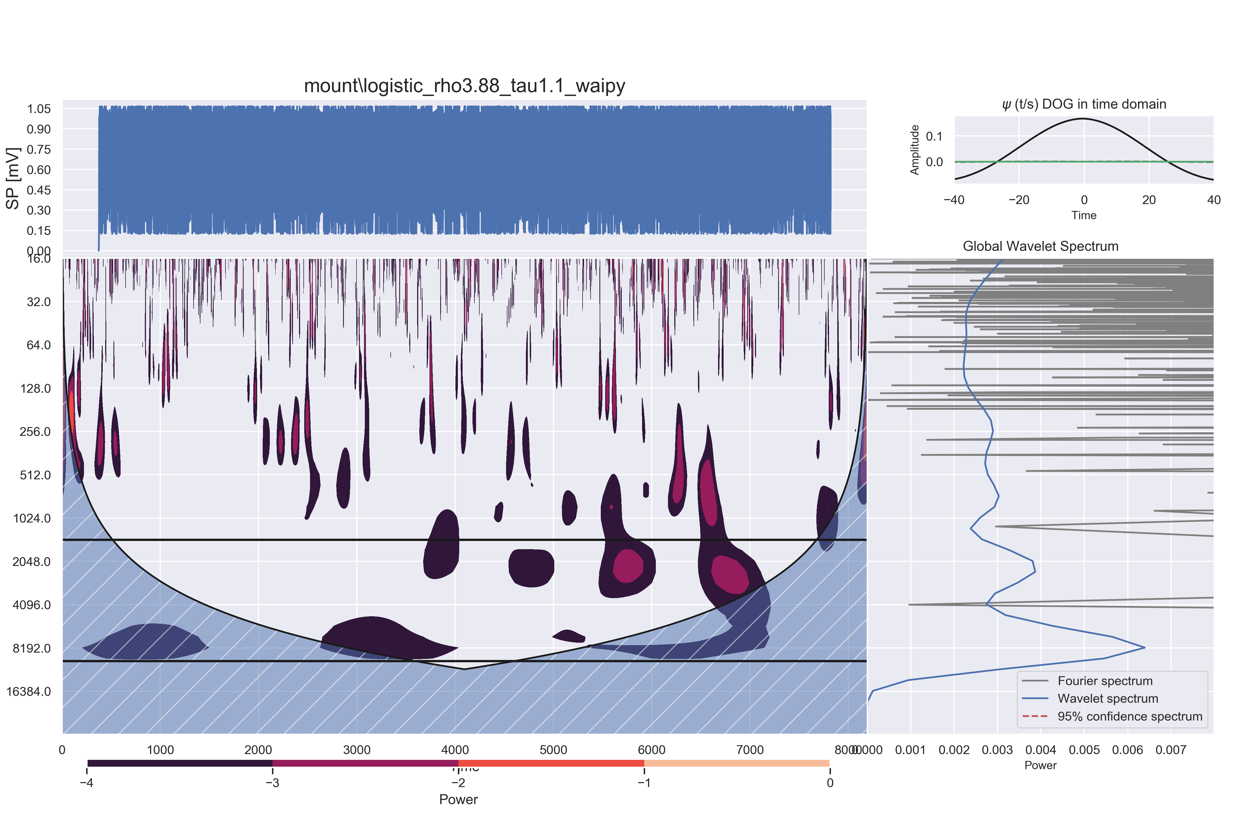

### Henon Map

#### Morley:

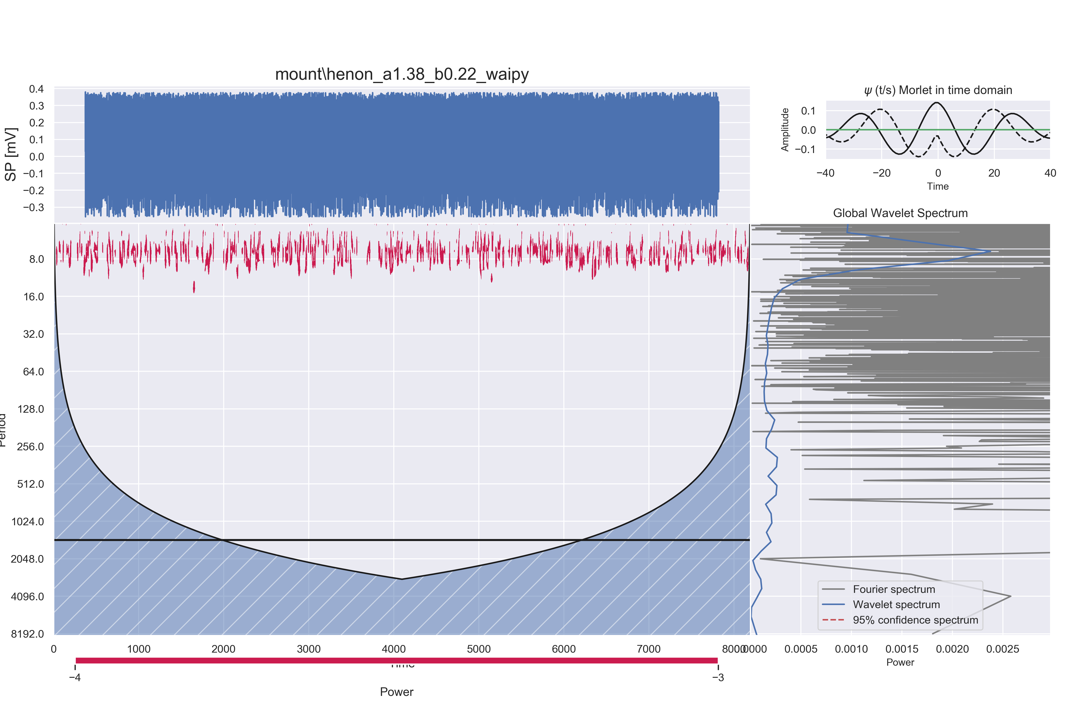

#### DOG could not be computed for Henon Map

The received error message was:   
Filled contours require at least 2 levels.

## Exercise 9

### Exercise 9.1

Due to the low diversity of numbers contained in a p-model generated time series, the aggregation used by the soc.py algorithm often produces few points or empty bins, resulting in poor charts for this generator.

## For endogenous series:

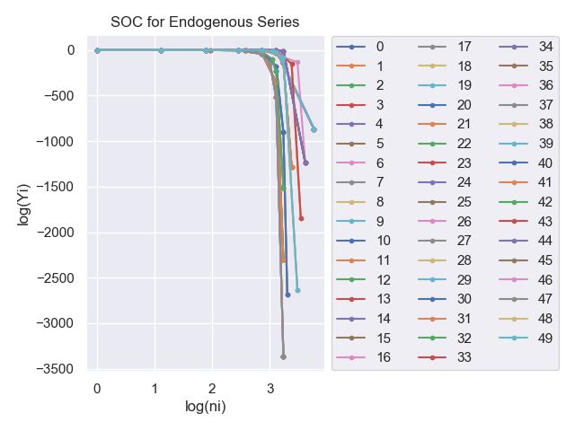

## For endogenous series:

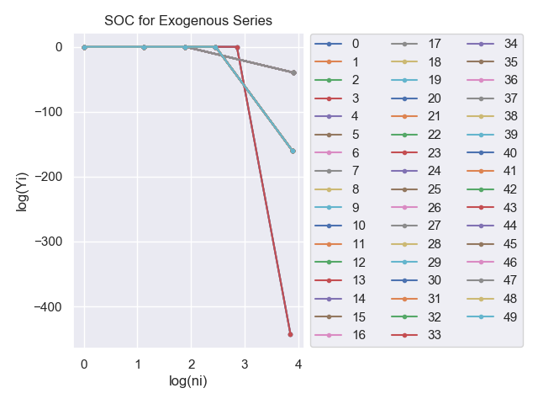

### Exercise 9.2

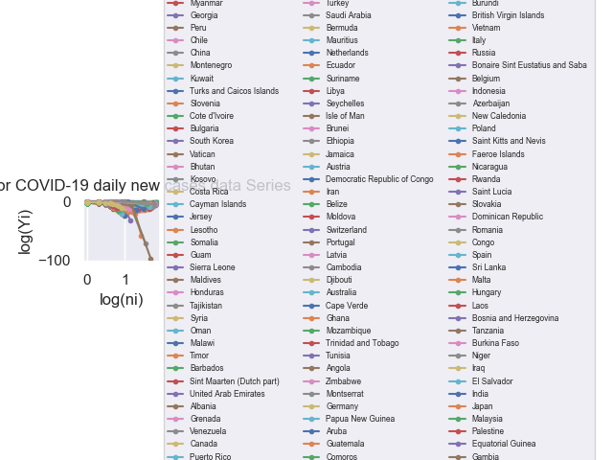

A few countries were excluded from this analysis, because they crashed the soc.py script, these are:Belarus, New Zealand, Paraguay, Estonia, Kenya, Ireland, Kazakhstan, Lithuania, Hong Kong, Finland, South Africa, Israel, Senegal, Bolivia, Morocco, Taiwan, Bangladesh, Colombia, Mexico, Croatia, Serbia, International, Nepal

Now, we repeat the process for a few select countries

